A New Way Forward
DOAS Flexible Benefits Premium Tool
Training Participant Guide
June 2023

Slide 1

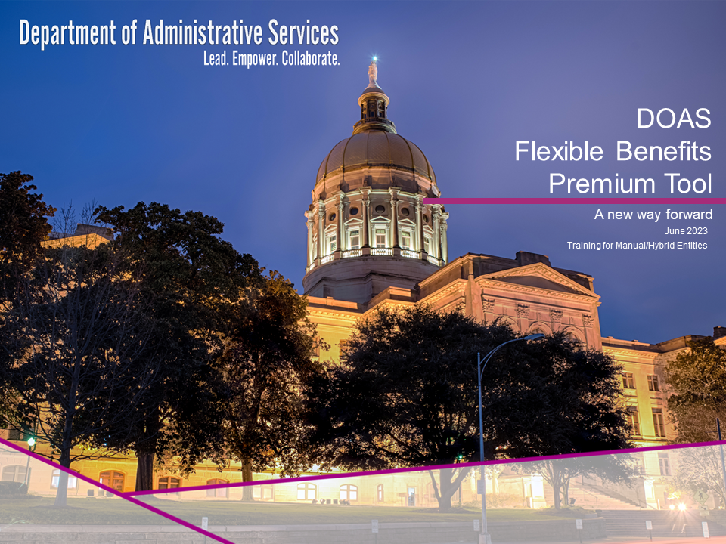

This training session is about the new Flexible Benefits Payment tool that is rolling out to Manual/Hybrid entities this month.
Flexible Benefits is intended to provide value to our employees when they are recruited and to retain them. It provides Dental insurance to our retirees. Alight provides the online portal and maintains program rules in the system. Alight also provides COBRA and Direct Billing services for employees on leave of absence or have terminated employment. The Department of Administrative Services, the State Accounting Office, and the benefit vendors, work with Alight to manage and support the program.
Alight (aka GaBreeze) is the “system of record” for the Flexible Benefits program. Based on January 1, 2023, coverage data, the annual premium total was $135,226,560. Your assistance is needed to ensure the program is compliant and data is maintained accurately.
Slide 2

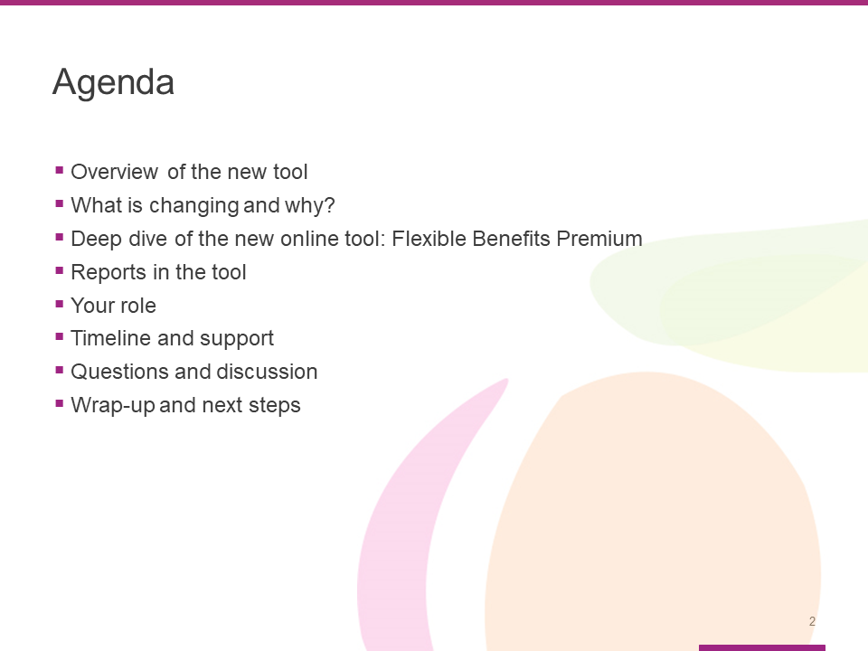

This training will cover the following topics:

- Overview of the new tool
- What is changing and why?
- Deep dive of the new online tool: Flexible Benefits Premium
- Reports in the tool
- Your role
- Timeline and support
- Questions and discussion
- Wrap-up and next steps

Slide 3

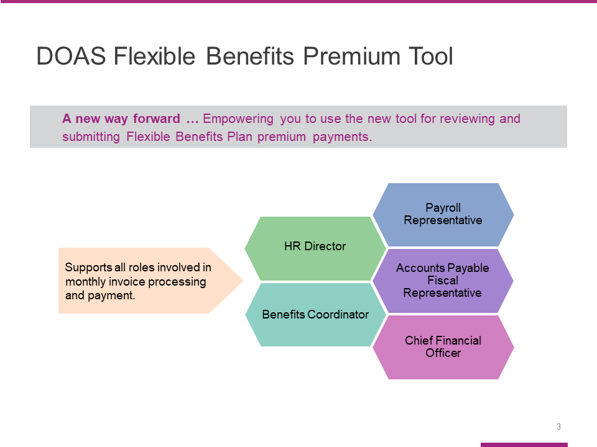
During this session, our goal is to equip and empower you to start using the new payment tool.
Notice the tag line, “A new way forward.” We selected it because this new tool is designed to simplify your workload and make the payment process faster and easier.
This training is designed to support all roles involved in monthly invoice processing, payment, and reconciliation including:

- HR Directors
- Benefits Coordinators
- Payroll Representatives
- Accounts Payable Fiscal Representatives, and
- Chief Financial Officers

Slide 4

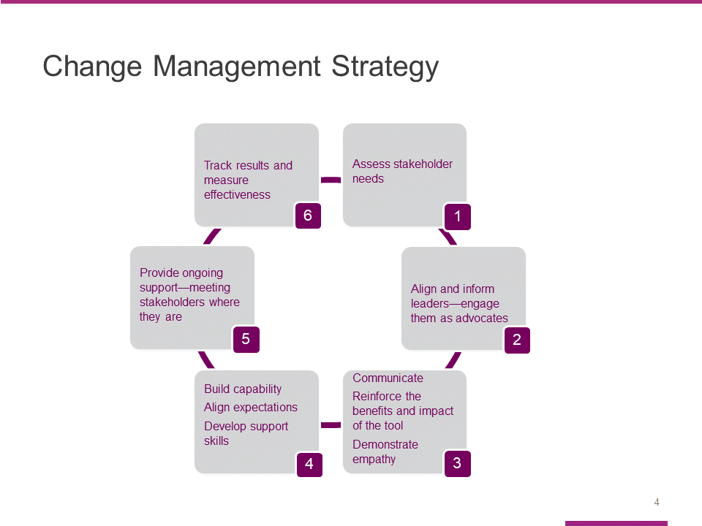

The change management strategy we developed to help you adopt the new Flexible Benefit Premium tool has six phases:

- We started by assessing the needs of our participating entities, who will be the primary stakeholders in this effort.
- We also focused on aligning and informing key leaders, so they are comfortable serving as advocates for the new tool.
- The third and fourth phases of our change management strategy are closely related.
  - Phase 3 centers around our commitment to communicating clearly – so entities can learn the benefits and expected impact of the new tool. At the same time, we want to demonstrate empathy. Change can be hard, even when it is for the better.
  - Phase 4 focuses on building capability by helping impacted entities get comfortable using the new tool, making sure you understand what is expected and helping you develop the necessary skills. Today’s training is a key component of Phase 4.
- Effective change management also requires that we provide impacted entities with ongoing support – by meeting you where you are in the learning/adoption process.
- The final component of our change management strategy is to track results and measure the effectiveness of our efforts.

Slide 5

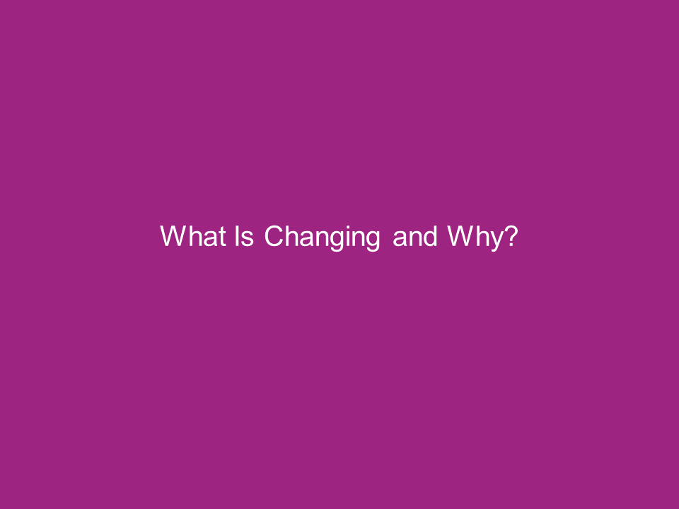

During this section, we will quickly recap what’s changing and why.

Slide 6

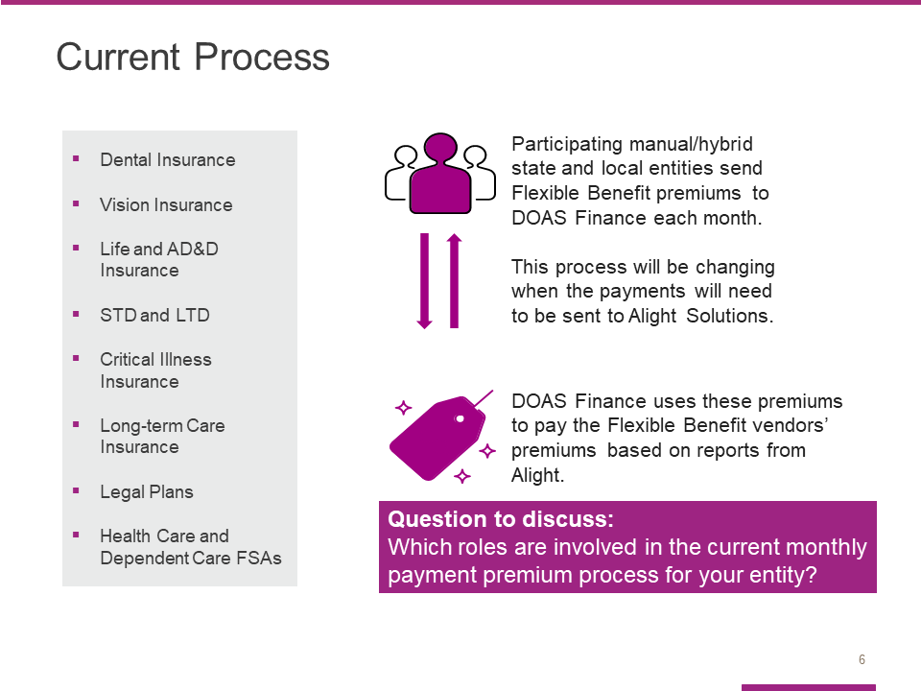

As you know, the Georgia Department of Administrative Services (DOAS), Human Resources Administration (HRA) division is dedicated to providing HR and talent management solutions that empower state entity HR and business leaders to manage their workforce in an effective and efficient manner.
One of the most critical services we provide is the administration of the State of Georgia Flexible Benefits Program, including:
- Dental Insurance,
- Vision Insurance,
- Life and AD&D Insurance,
- STD and LTD (Short-Term Disability and Long-Term Disability),
- Critical Illness Insurance,
- Long Term Care Insurance,
- Legal Plans, and
- Flexible Spending Accounts for Health Care and Dependent Care.
The visual on the right of the slide illustrates how the monthly process works, and how it will need to work going forward.
Currently, participating manual/hybrid state entities send Flexible Benefit premiums to DOAS Finance each month. This process will be changing in June when the payments will need to be sent to Alight Solutions.​
DOAS Finance uses these premiums to pay the Flexible Benefit vendors’ premiums based on reports from Alight. ​
Because this process is complex and time-consuming, DOAS and Alight have partnered to improve the process through a more streamlined and efficient online tool.
Question to consider: What key roles handle this process for your Entity? What are their responsibilities?

Slide 7

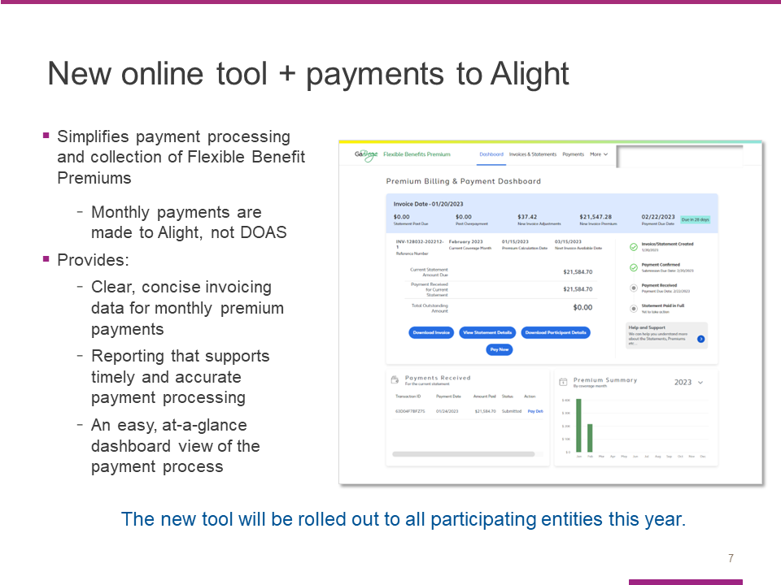

To address these challenges and simplify your work effort, we have partnered with the GaBreeze Benefits System administrator, Alight Solutions, to develop a new online tool that will replace this process.
This tool will provide us with a system that provides clear, concise invoicing data for premium payments, as well as reporting that supports timely and accurate payment processing and reconciliation.
It was developed specifically for DOAS and you, our participating entities.
More importantly, it is designed to simplify payment processing and collection – providing you with easy, online access to clear and concise statements, invoices and reports.
And here’s the best news: The new tool is rolling out to all participating manual/hybrid entities now. You will start using the tool for upcoming invoices starting in June.
Slide 8

In this section, we will take a closer look at the new tool.

We will start by reviewing the key features using screen shots.

Slide 9

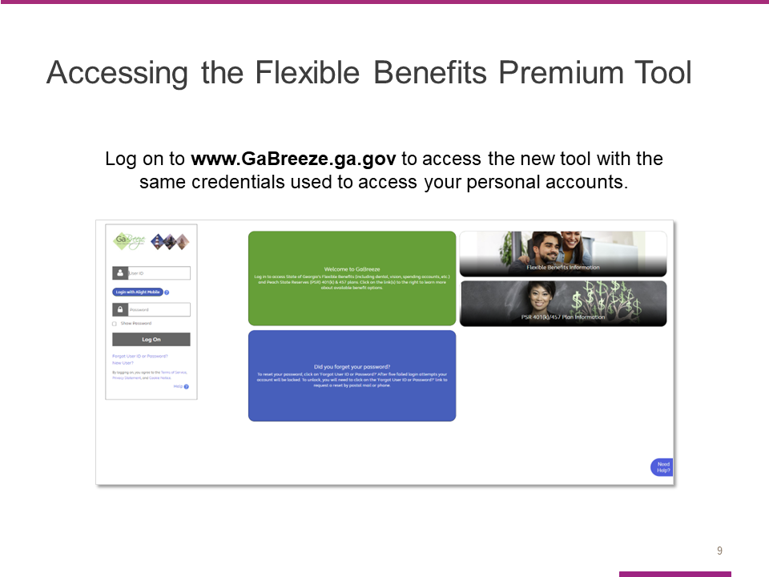
Going forward, you will use the Flexible Benefits Premium tool to view your remaining outstanding premium amount to make applicable payments.

All authorized users will access the new online tool through the UPoint GaBreeze site at www.GaBreeze.ga.gov (under the Administrative Tools section).

You will need your User ID and password to authenticate into the site.

If you do not remember your credentials, select the Forgot User ID or Password link under the Log On button. Then follow the prompts to reset your credentials. If you need to reset your credentials, if you have a cell phone number online in the portal, you can receive a one-time code to update your password.

Otherwise, your password will be sent you via the US Postal Service.

If you are new to the site, select the New User link, also under the Log On button, and then follow the prompts to set up your credentials.

Finally, please note that the User ID and password are the identification credentials used to access their personal accounts and not the User ID used to access the normal GaBreeze Employer Portal.

Slide 10

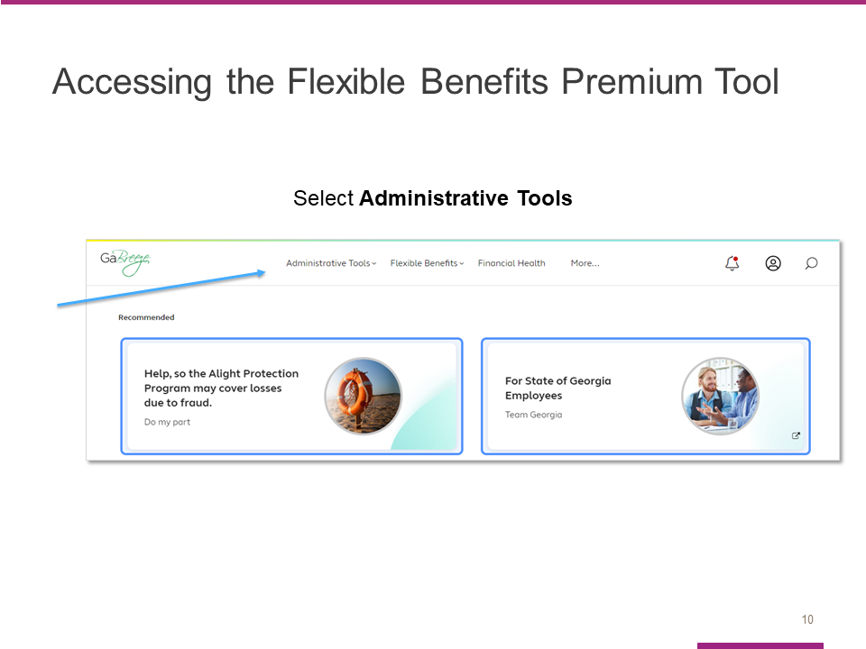

Once you are logged into the GaBreeze site you can access the Flexible Benefits Premium tool via the top drop-down menu.
Entity users who have been granted access to the tool will see an Administrative Tools drop-down on the far left, at the top of the page.
Selecting this drop-down will route the entity user to a page which will link directly to the Flexible Benefits Premium tool.

Slide 11

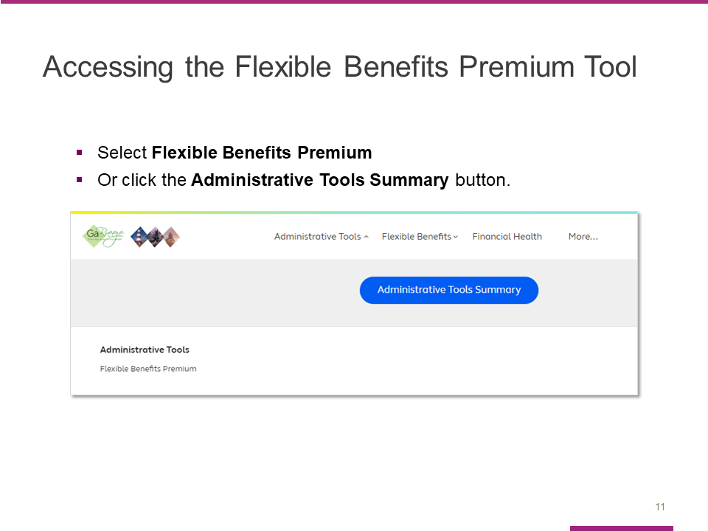
After you select the Administrative Tools drop-down, you will see this page. The words Flexible Benefits Premium are a direct link to the tool.
In addition, a new Administrative Tools Summary button appears. This is where Alight will be storing access to multiple tools, including the Flexible Benefits Premium.
Clicking on this button will take you to the Tools Summary page.

Slide 12
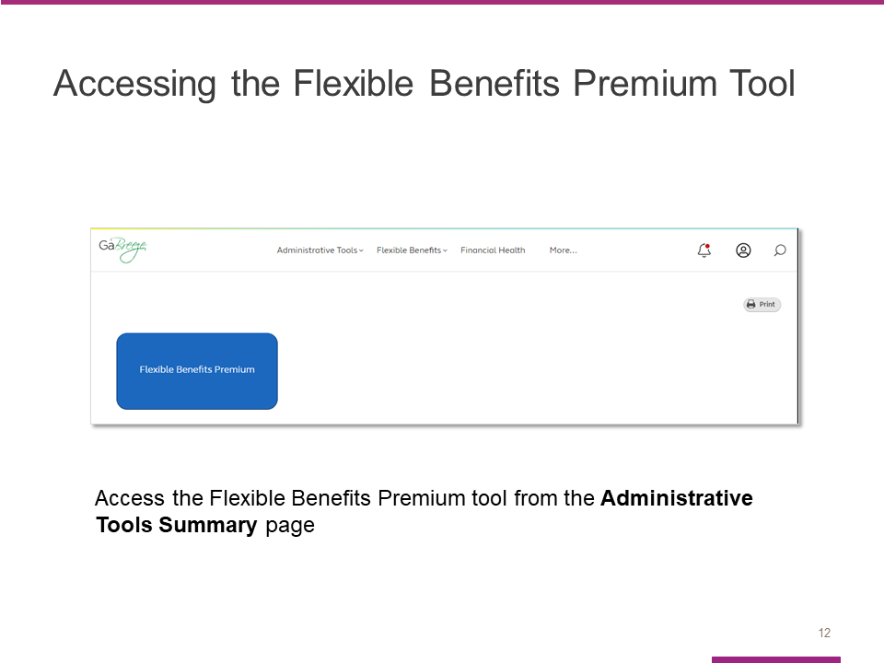

The Flexible Benefits Premium tile can also be clicked on this page and will route the entity user directly into the Flexible Benefits Premium tool.

Slide 13

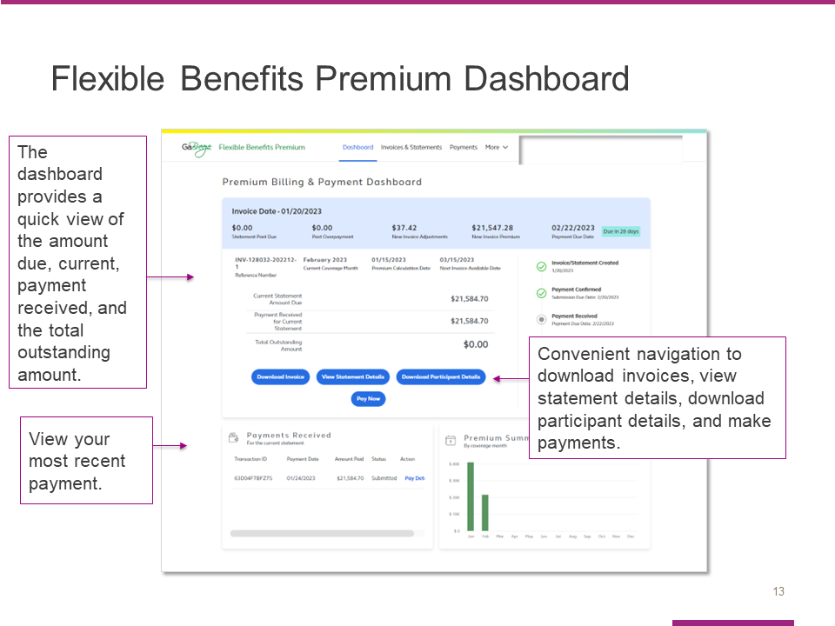

This dashboard is the first screen you will see after you access the new tool.

It provides an easy, at-a-glance view of the payment process.

The light blue bar at the top shows the invoice date as well what makes up the current amount due, specifically:

- The new invoice premium,
- The new invoice adjustments, and
- Any past due amounts.

This section of the dashboard also shows the invoice/statement date and the payment due date.

The section under the blue bar shows the current statement amount due, the payment received for the current statement, and the total outstanding amount.

You can use the dark blue buttons to download the invoice, view statement details, download participant details, or pay.

The Payments Received section allows you to view your most recent payment.

Slide 14

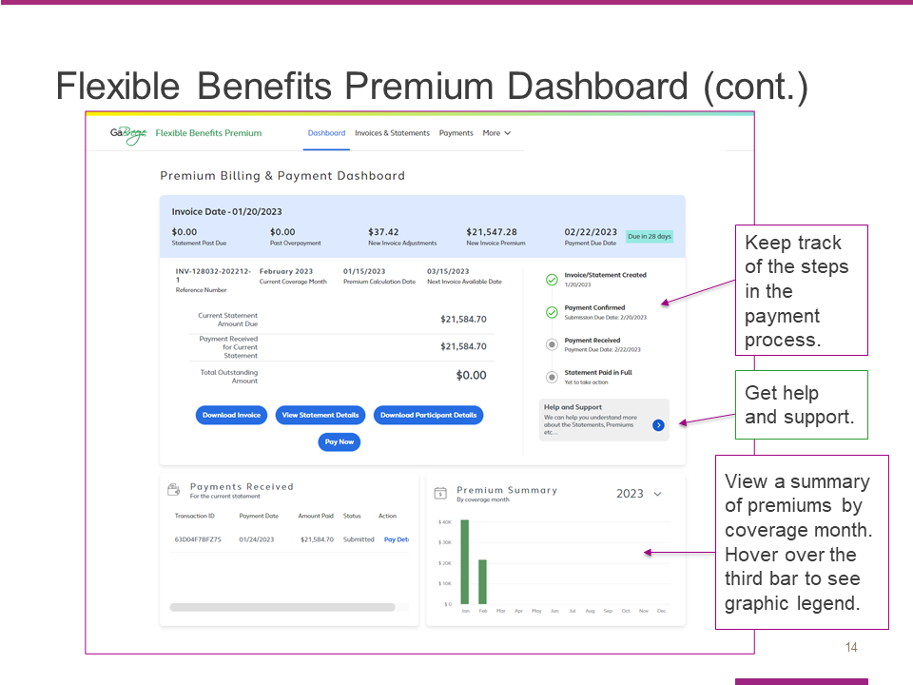

On the right side of the dashboard, you will see a tracker that helps you keep track of where you are in the payment process.

You will also find a help and support button that connects you to additional resources.

The bottom section of the dashboard allows you to view payments received as well as a premium summary.

You may also hover over the third bar to see the graphic legend.

Slide 15

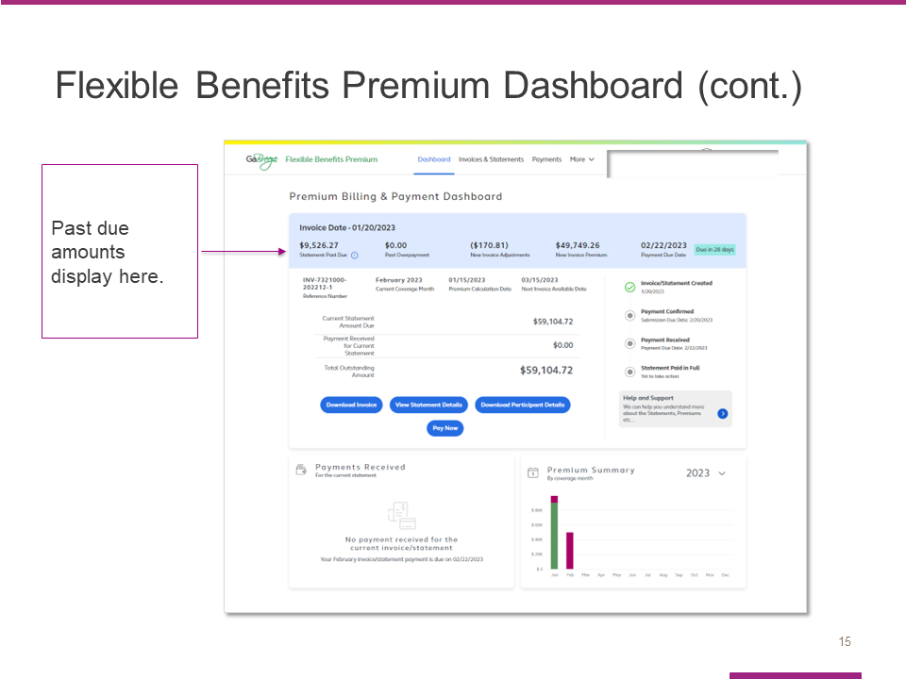

The tool allows you to easily view past due amounts from the Invoice Date light blue section at the top of the page.

Slide 16

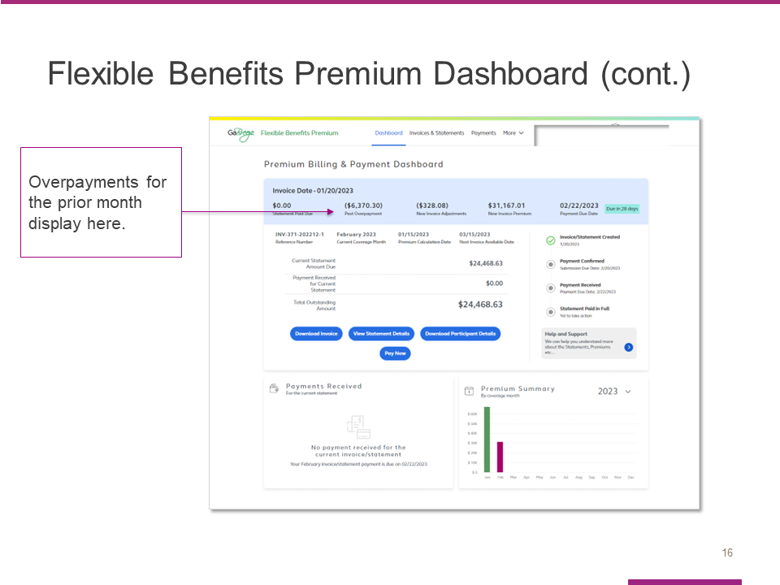

The Invoice Date section also shows any overpayments for the prior month.

Slide 17

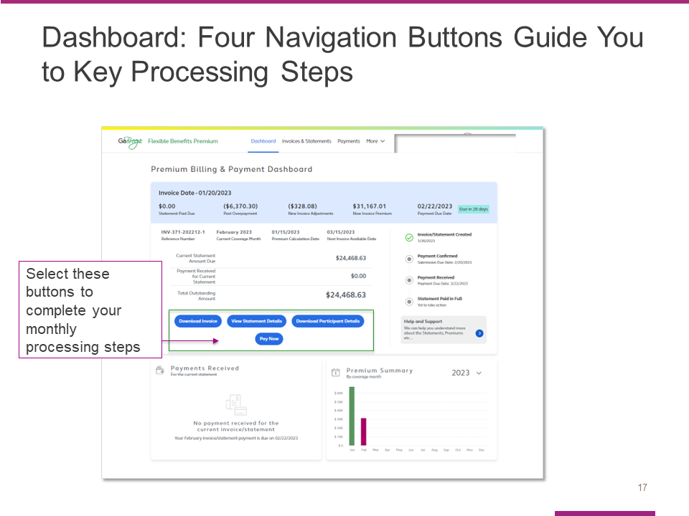

The four blue navigation buttons are another important feature of the dashboard.

These buttons are designed to guide you through the four key invoice processing steps each month:

- Downloading the invoice
- Viewing statement details
- Downloading a file with participant details, and
- Paying the invoice.

Slide 18
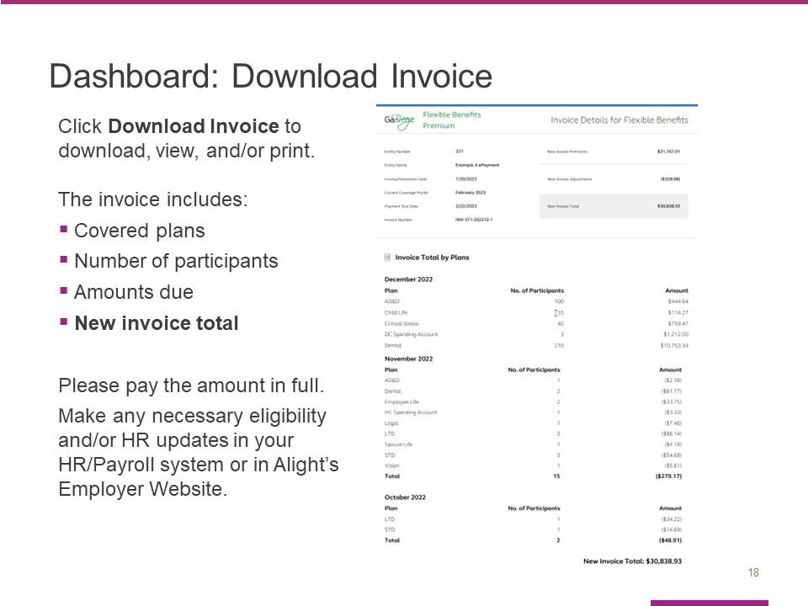

When you select the Download Invoice button from the dashboard, the tool will open your most recent invoice.

It is important to check the invoice to confirm the following information for each month:

- Covered plans,
- Number of participants, and
- Amounts due.

The new invoice total is shown at the bottom of the invoice.

Please pay the amount in full.

If any eligibility and/or HR updates are needed, please make them in your HR/Payroll system.

Manual entities will use the Employer Website tool for updates to Alight.

Slide 19

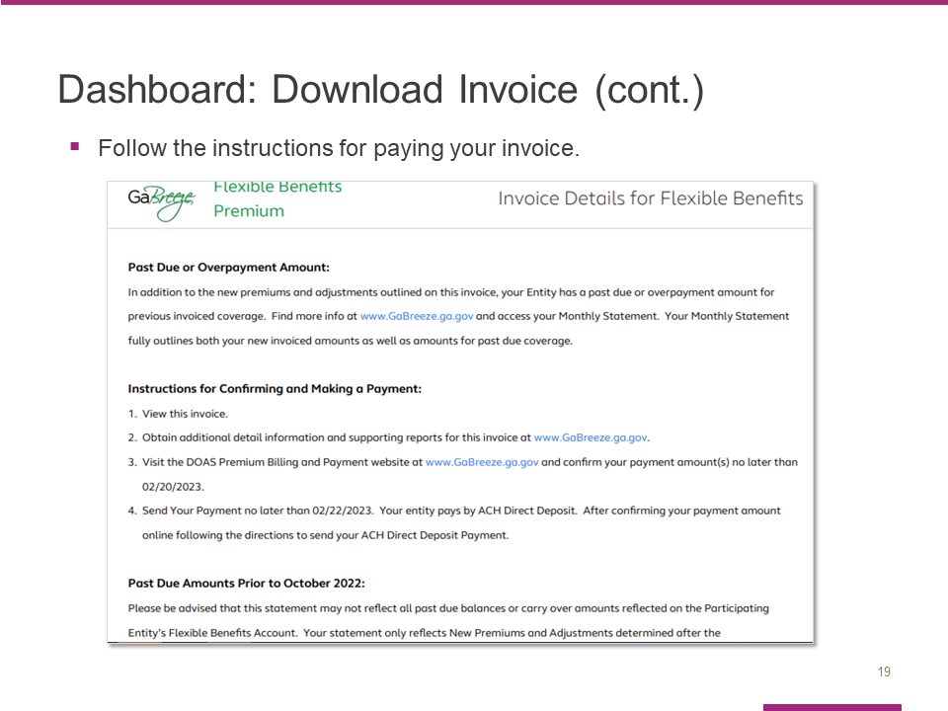

Be sure to follow the instructions provided when you pay your invoice.

Slide 20

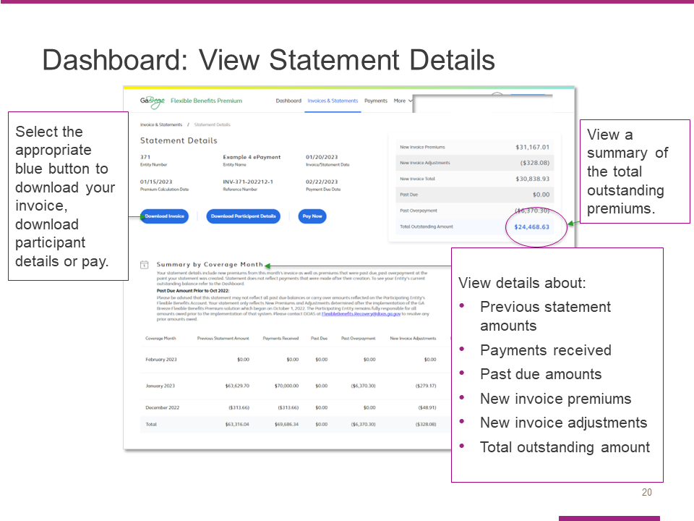

When you select the View Statement Details button, you will link to the Statement Details page that is shown here.
You can use the three blue navigation buttons to download your invoice, download a file with participant details or pay.
This page also provides a summary of the total outstanding premiums, as well as a Summary by Coverage Month section with details about:
- Previous statement amounts,
- Payments received,
- Past due amounts,
- New invoice premiums and new invoice adjustments, and
- The total outstanding amount.

Slide 21

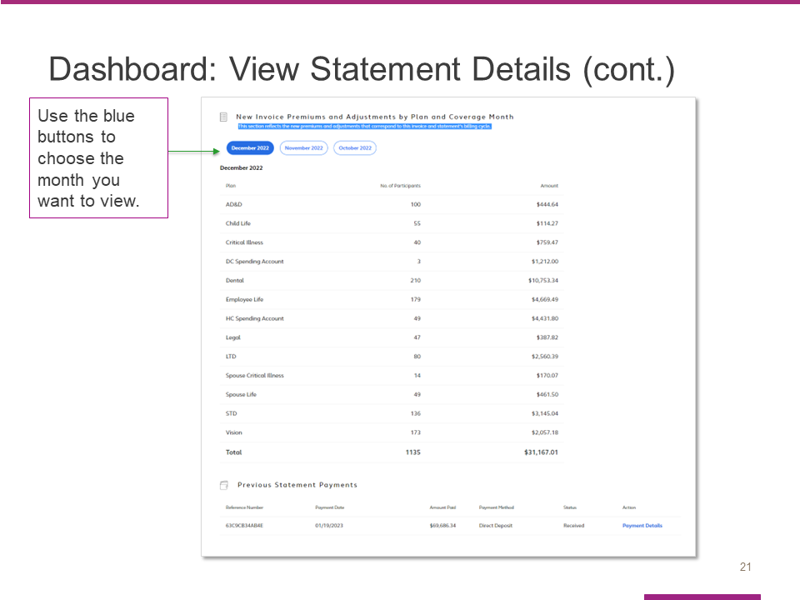

Here is a screen shot of the additional information you’ll see as you scroll through the statement screen.
Use the blue buttons to choose the month you want to view.

Slide 22

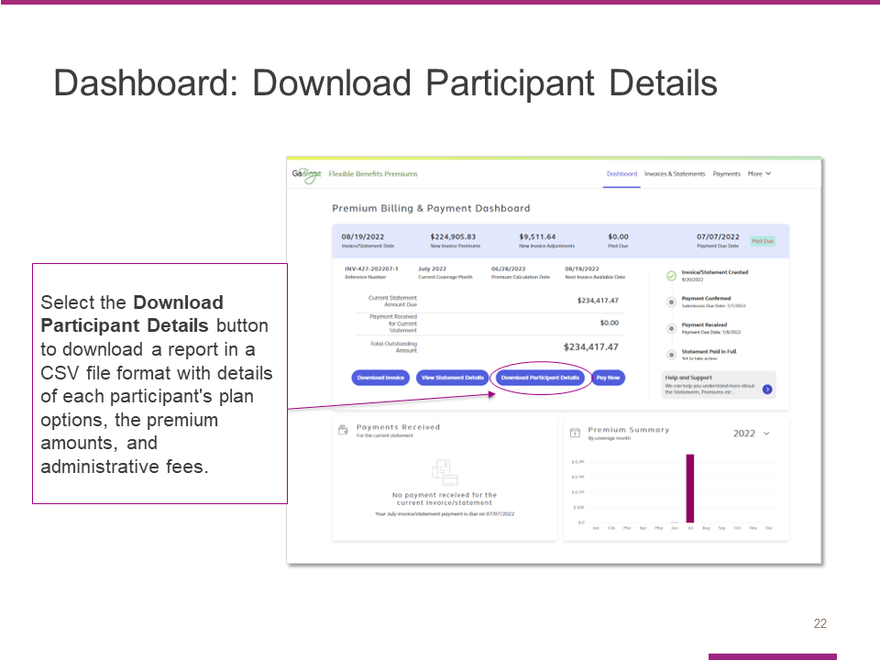

After you select the Download participant details button, the tool will download a report in a CSV file with details of each participant’s plan options, the premium amounts and administrative fees.

Review this file to confirm the number of participants covered since that is what determines the premium amounts due.

Slide 23

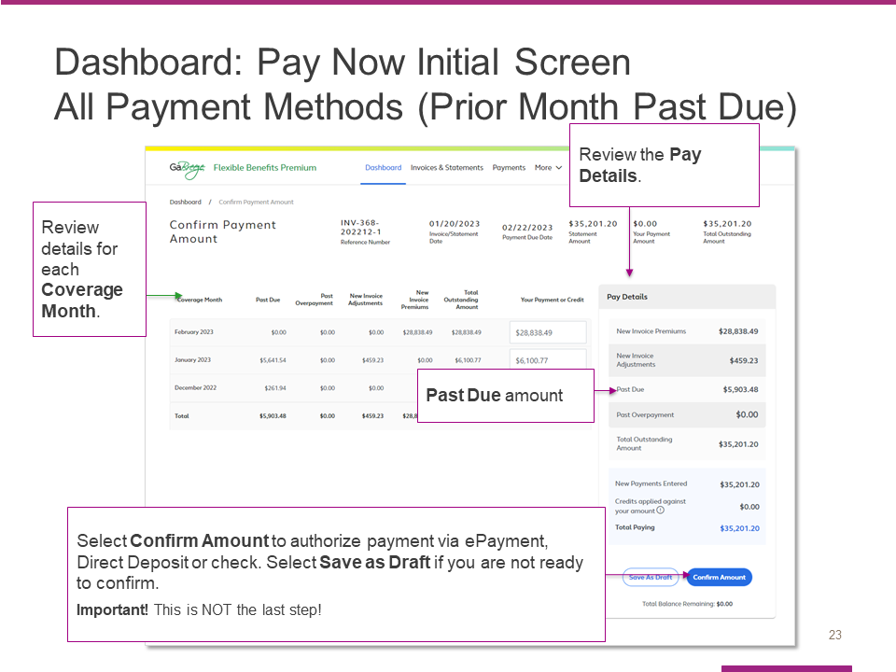

Here is the screen that appears when you select the Pay now button from the dashboard. This initial screen is the same whether your entity pays by ePayment, Direct Deposit or Check – with one exception that will be covered later.

Start by reviewing the details for each Coverage Month.

- Coverage Months correspond to the actual coverage of your employees. However, Coverage Months premiums are not always calculated in the actual month of coverage. This is because retroactive enrollments (such as a birth of a child enrolled in coverage after birth) can adjust previous months coverage.
- Therefore, in each invoice you will likely see nearly all your premiums in the current Coverage Month, but you may also see adjustments to previous Coverage Months.
- Adjustments can be both positive (additional money due) or negative (credits against other premiums due).

The next step is to review the pay details for the current amount due.

When you have completed that step, hit Confirm Amount to authorize your payment via ePayment, ACH or check (depending on your entity). Note that this is not the last step in the confirmation process. It simply takes you to the NEXT steps in the payment/confirmation process.

If you are not ready to confirm and pay, you can select Save as draft before you leave the page.

Please note, If the amount Confirmed is not the exact same amount Alight Received, the issue will appear on Alight’s Unallocated Report. Alight reviews this report daily and will delete the Confirmed amount in the tool if the amounts do not match. The entity will need to enter a new Confirmed Amount. These are manual processes, and entities need to ensure that after they receive their monthly invoices, that the appropriate amounts are Confirmed and Paid timely, and for the Reconciliation process that the Alight and Payroll reports are reviewed, so the appropriate updates can be made to the HR/Payroll system and/or Alight’s Employer Website.

Refer to the FAQs for help on how to enter payment data.

This screen is the same for all 3 payment methods just mentioned. However, the next steps and screens differ by payment method. As a result, there is a different message at the bottom of this screen with specific information about next steps for each payment method.

Note: This example shows a Past Due amount from the prior month of $5,903.48. This Past Due amount is ADDED to the Total Outstanding Amount on this screen.

Slide 24

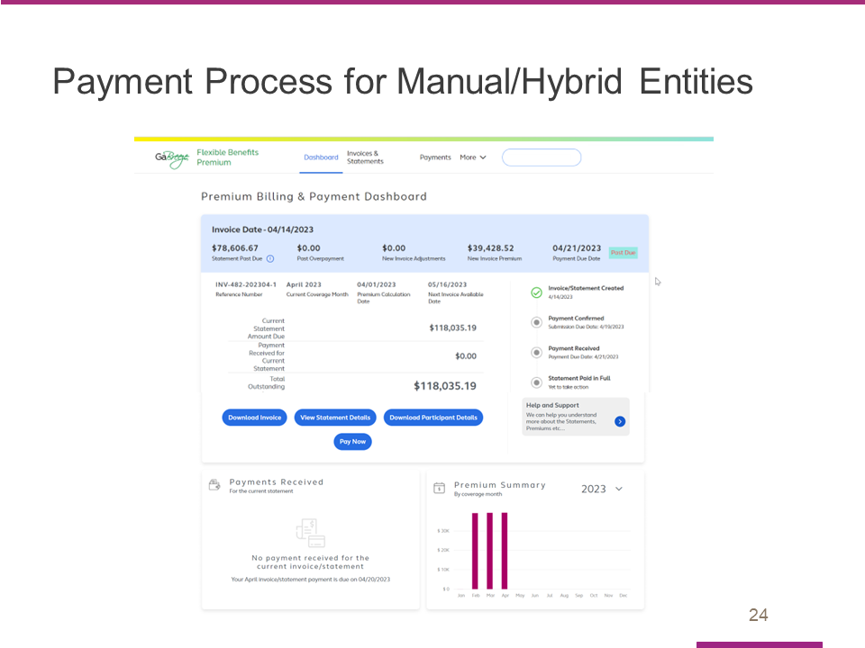

- Now let’s take a closer look at what the process looks like for manual and hybrid entities.
- In this example, the entity has a current month outstanding amount of $118,035.19.
- That amount consists of a past due balance of $78,606.67 and a new invoice amount of $39,428.52.

Slide 25

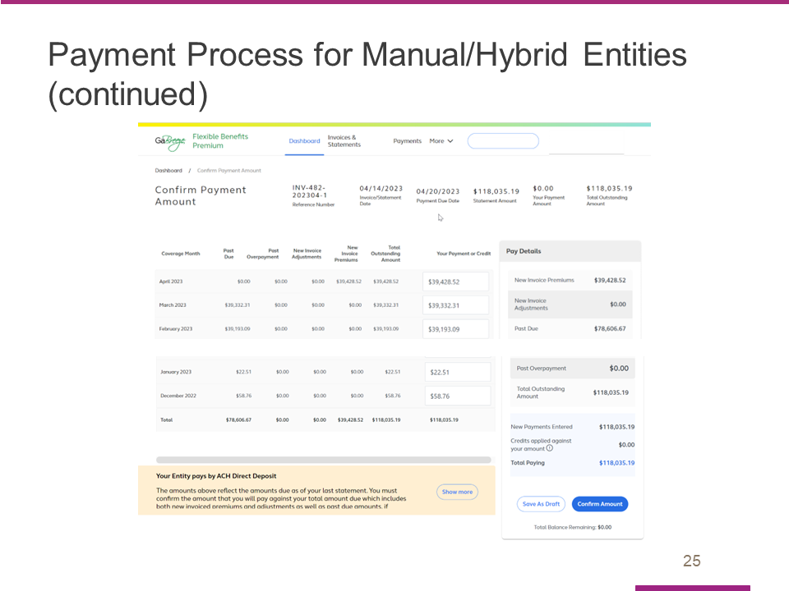

- Clicking on the Pay Now button brings us to the Confirm Payment Amount.
- In this example the entity will be making a partial payment.
- When you get to the Confirm Payment page it shows the amounts due by Coverage Month, this is based on the Premiums for each month of coverage.
- The tool autofills the Your Payment or Credit column based on the premiums and/or adjustments for each month of coverage.

Slide 26

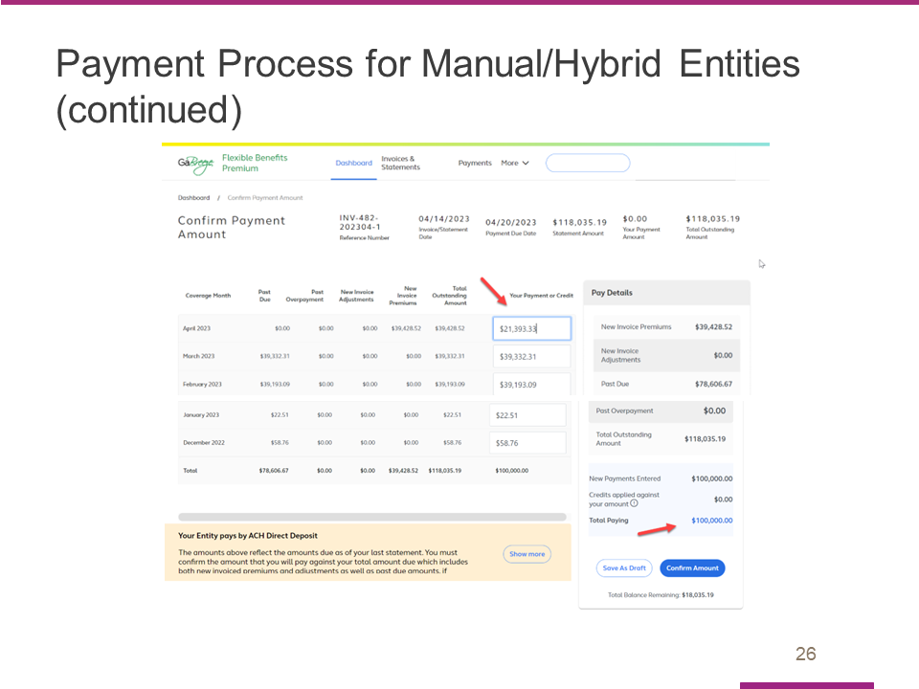

- In this example the entity has $100,000 on hand to make a payment.
- Because the entity cannot make the full $118,035.19 amount due at this time, the entity then updates the amount in the respective coverage months to get to a payment amount of $100,000. Therefore, the amount being paid for the most recent coverage month needs to be reduced by $18,035.19 by manually entering $21,393.33 in the current coverage month for May 2023. The amounts for the months below the current coverage month remain the same as displayed in the Total Outstanding Amount column for each prior month.
- As you can see, the Tool adjusted the amounts on the right side of the screen to show that my new total payment is $100,000 matching the amount I plan to Confirm and then pay to Alight.
- The tool also shows that I still have a balance remaining of $18,035.19 after I make this payment. I then have to click on Confirm Amount via the blue button.

Slide 27

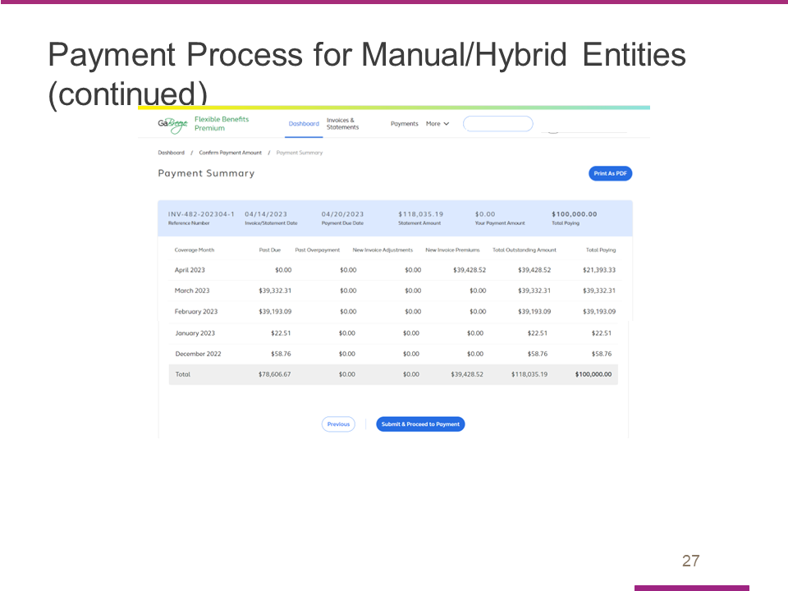

- I then see the amounts being paid on the Payment Summary page.
- Again, this matches the $100,000 I am paying partially.
- To formally confirm this amount, I’ll click on Submit & Proceed to Payment.

Slide 28

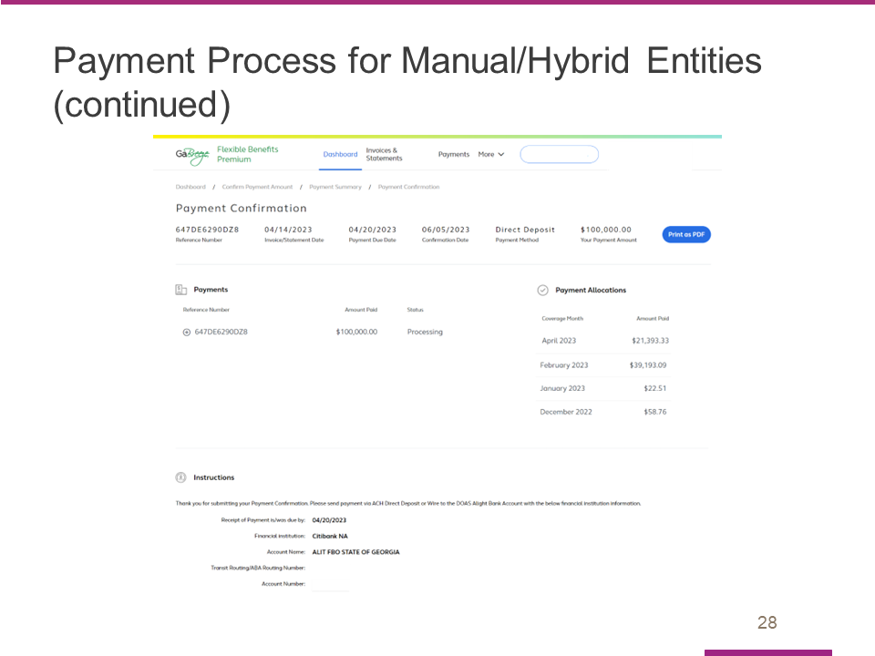

- Here is the Payment Confirmation page.

Slide 29

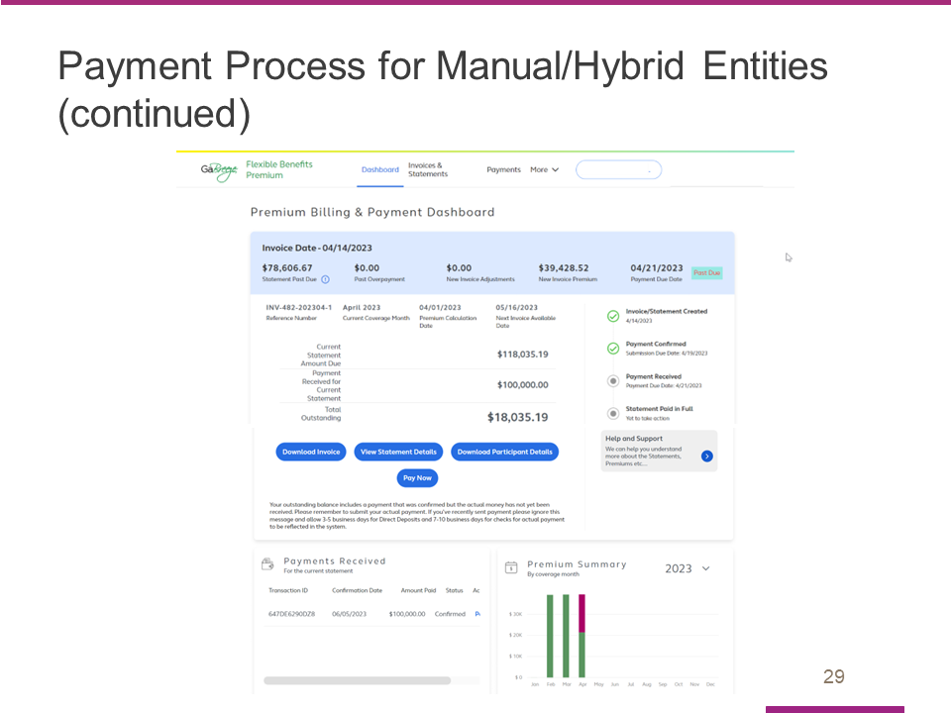

- Returning to the Dashboard for reference, you can see the $100,000 has been Confirmed and that the remaining balance exists.

Slide 30

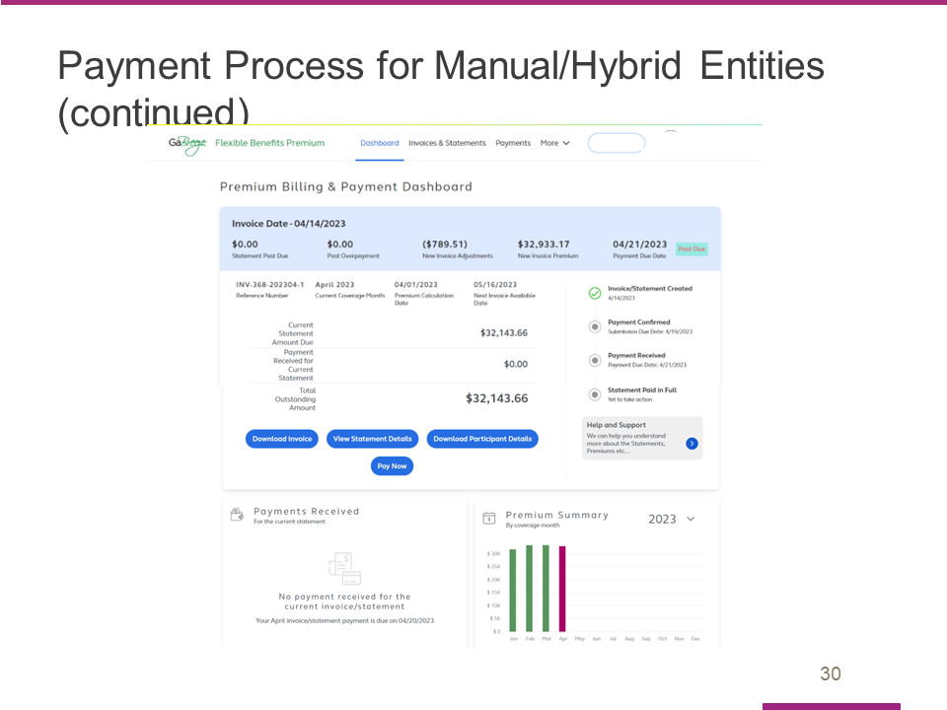

- In this example, the entity in question has a current month outstanding amount of $32,143.66.
- That amount consists of a past due balance of $0.00, adjustments of $789.51 and new invoice premiums of $32,933.17.

Slide 31

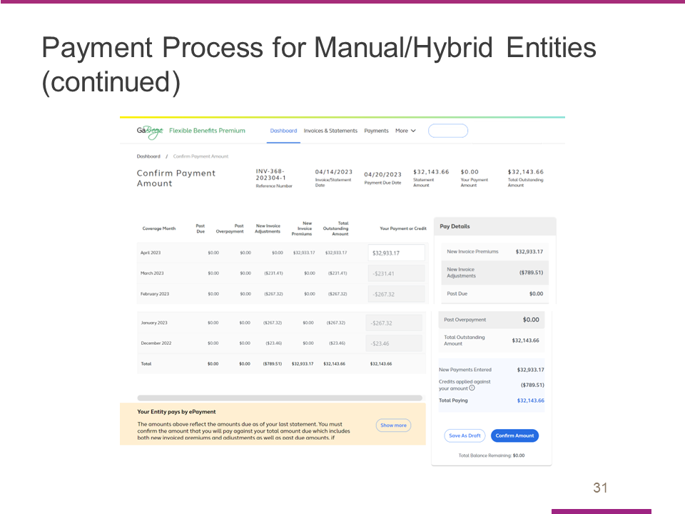

- Clicking on the Pay Now button brings us to the Confirm Payment Amount.
- Here, the entity will be making an overpayment.
- On the Confirm Payment page, the tool shows the amounts due by Coverage Month, this is based on the Premiums for each month of coverage. The tool autofills the Your Payment or Credit column based on the premiums and/or adjustments for each month of coverage.

Slide 32

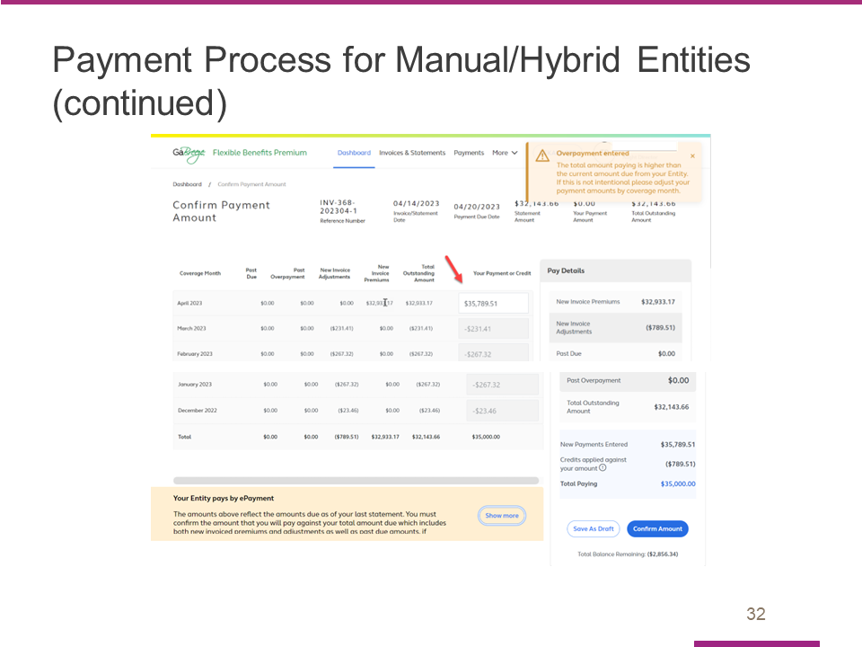

- In this example, the entity has $35,000 on hand to make a payment.
- This is greater than the current total outstanding amount, but within the threshold of allowable overpayments.
- The entity then updates the amount in the respective coverage months to get to a payment amount of $35,000. In this example the entity increased the amount being paid for the most recent coverage month by $2,856.34 by manually entering $35,789.51.
- The Tool adjusted the amounts on the right side of the screen to show that my new total payment is $35,000 matching the amount the entity would like to Confirm and then Pay to Alight.
- The tool also shows that after this I will have a negative balance of $2,856.34 thus highlighting an overpayment was made. I then have to Confirm Amount via the blue button.

Slide 33

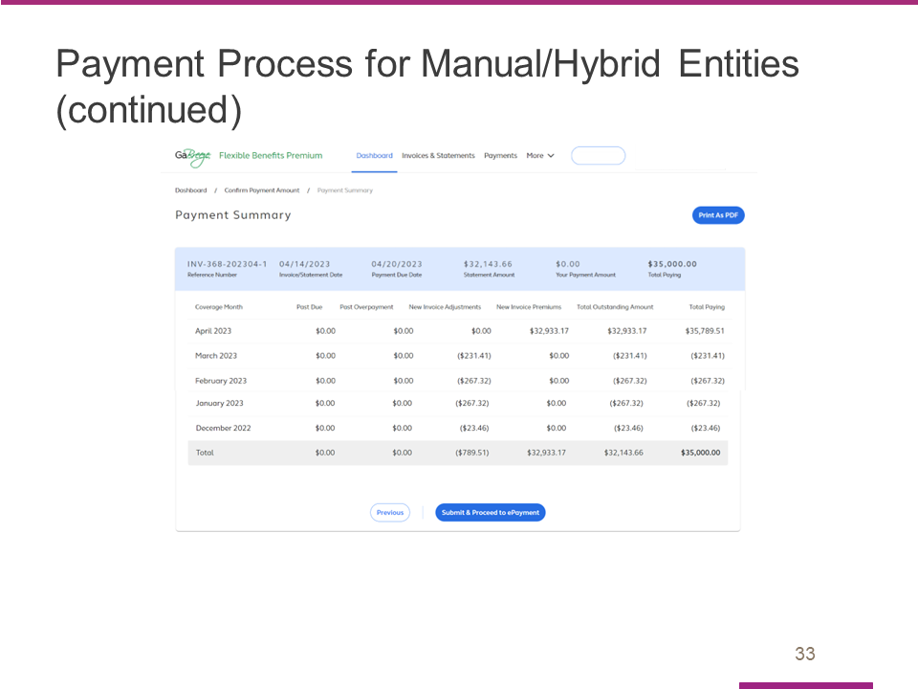

- I then see the amounts being paid on the Payment Summary page.
- This matches the $35,000 the entity is paying. The entity will click on Submit & Proceed to Payment to formally confirm this amount.

Slide 34

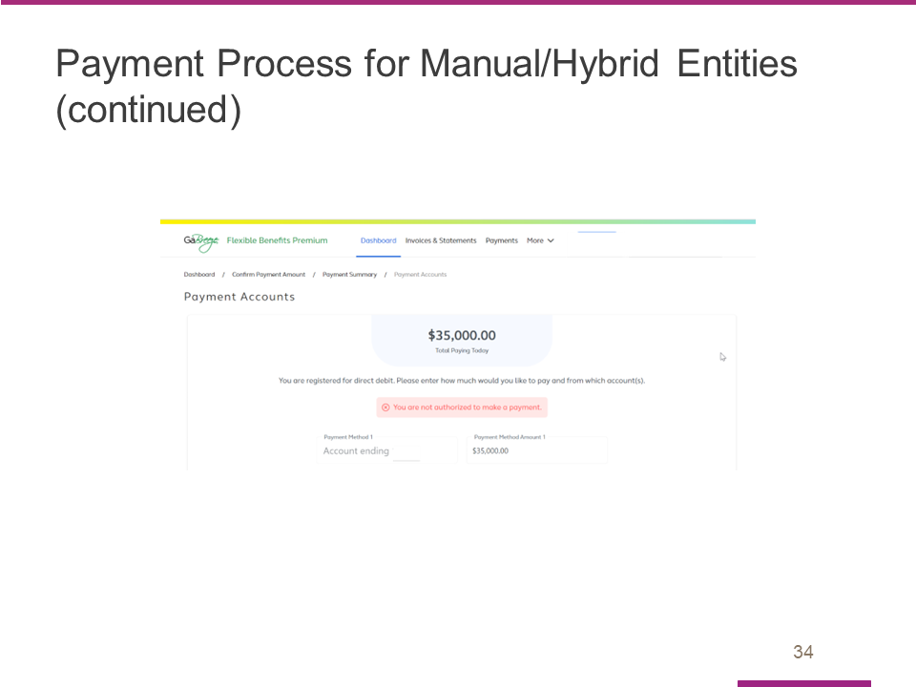

- In this example the entity is an ePayment entity. On this page the entity is making the ePayment request to allow Alight to take this $35,000 payment from our accounts.
- The user must be an entity approved ePayment requestor to proceed.

Slide 35

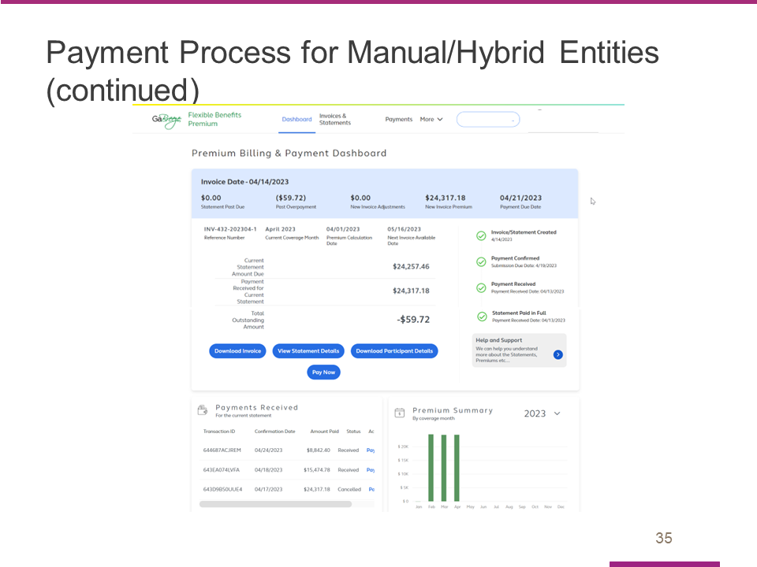

- In this test environment example, we cannot proceed to make an ePayment, but below is the Dashboard sample of another entity that overpaid.
- You can see the negative remaining balance showing they overpaid which will carry over to the next invoice.

Slide 36

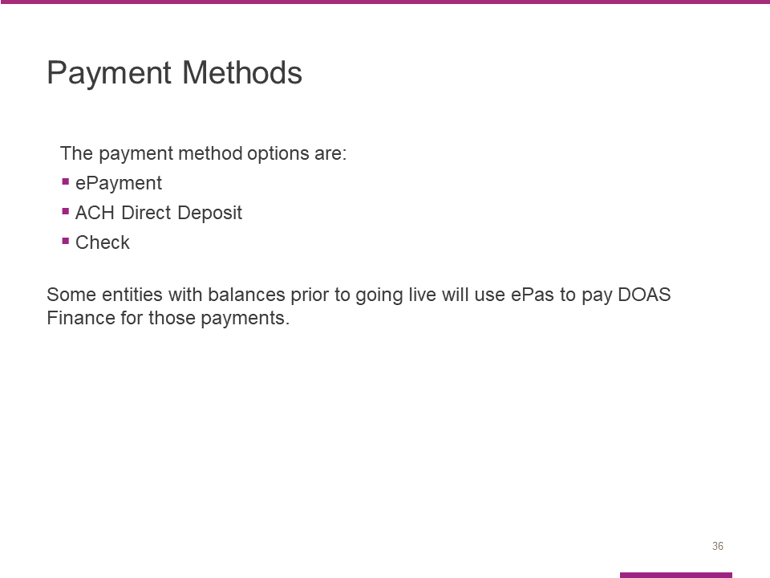
Participating entities need to choose one of these forms of payment.

- ePayment – A preferred option that replaces ePas for Manual/Hybrid entities.
- ACH Direct Deposit
- Check

Some entities with balances prior to going live (in June) will use ePas to pay DOAS Finance for those payments.

We’ll cover the payment steps for each form of payment next.

Slide 37

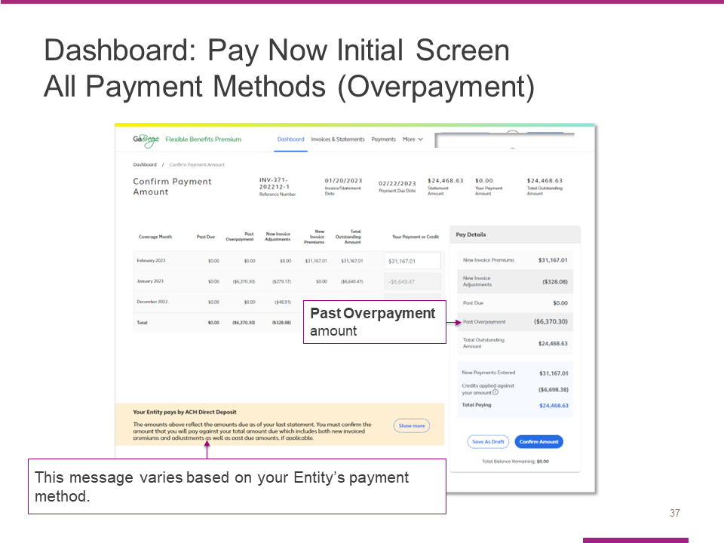

This screen shot is identical to the one we just viewed with one exception: Instead of showing a Past Due amount for the prior month, it shows a Past Overpayment amount.

As you can see, the Past Overpayment is SUBTRACTED from the Total Outstanding Amount.

Note: The message in the tan box at the bottom of the screen varies by payment method. This example shows the message for Entities that pay by ACH Direct Deposit. If your Entity uses a different payment method, you will see a different message.

Slide 38

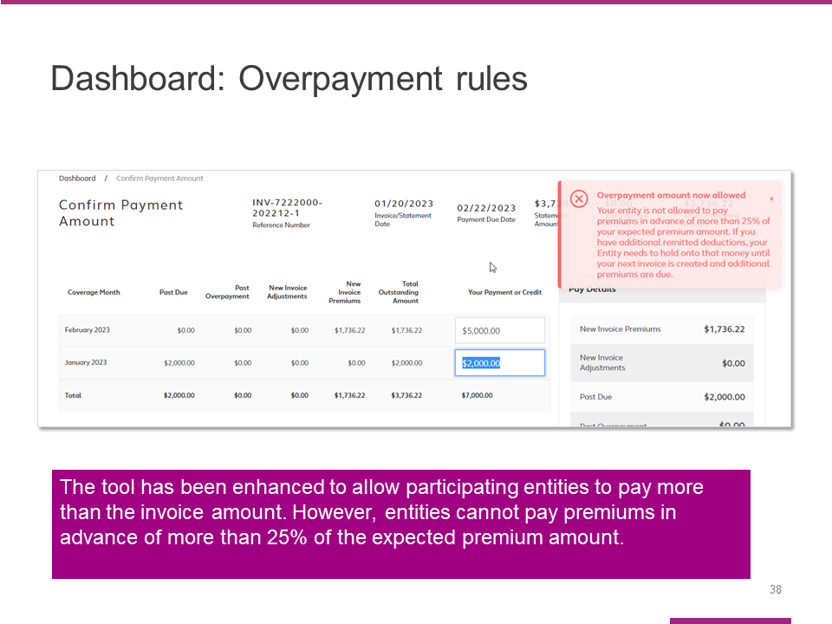

All entities can make overpayments if they so desire.

However, there is a limitation on how much they can overpay.

That limit is no more than 25% of total outstanding balance for the current cycle.

An entity that attempts to pay more than the limit will see the Overpayment Edit shown on this screen shot.

Slide 39

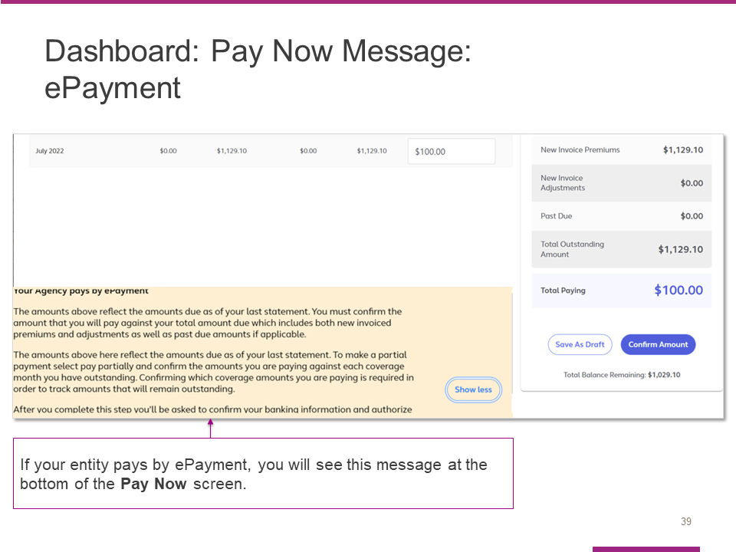

If you are paying by ePayment, you will see this message at the bottom of the Pay Now Screen. Please review before you select Confirm Amount.

Slide 40

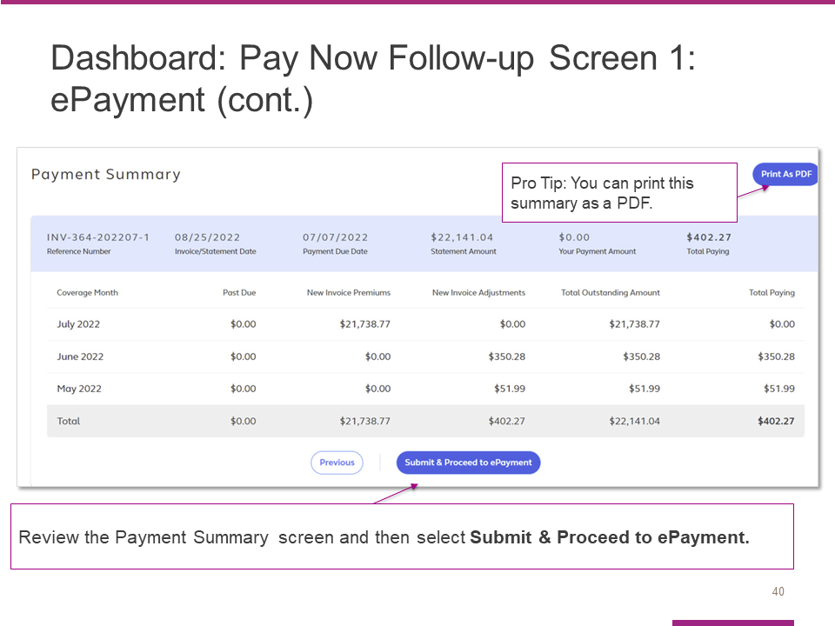

You will see this Payment Summary Screen after you select Pay Now.

Review the summary for each month and select Submit & Proceed to ePayment.

For entities that are paying via ePayment, the authorization to formally submit the payment will be limited to the AP Fiscal Representative and Chief Financial Officer at the entity.

Slide 41

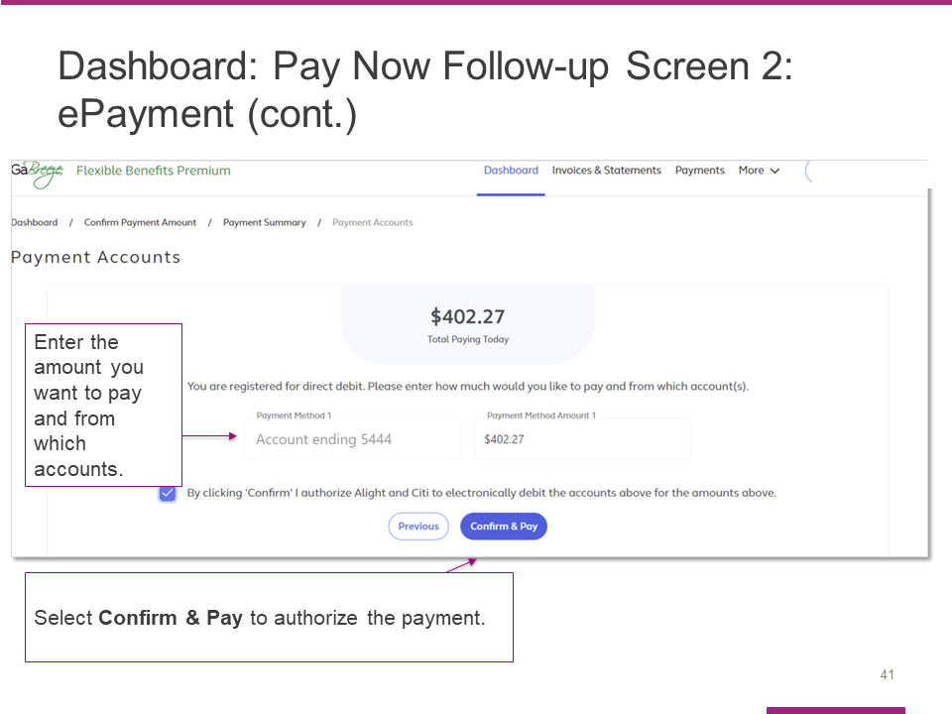

Here is the screen that appears after Submit & Proceed to ePayment is selected.

The AP Fiscal Representative or Chief Financial Officer will need to enter the amount they want to pay and indicate the bank account the payment should be taken from.

Their final step is to select Confirm & Pay to authorize payment.

Slide 42

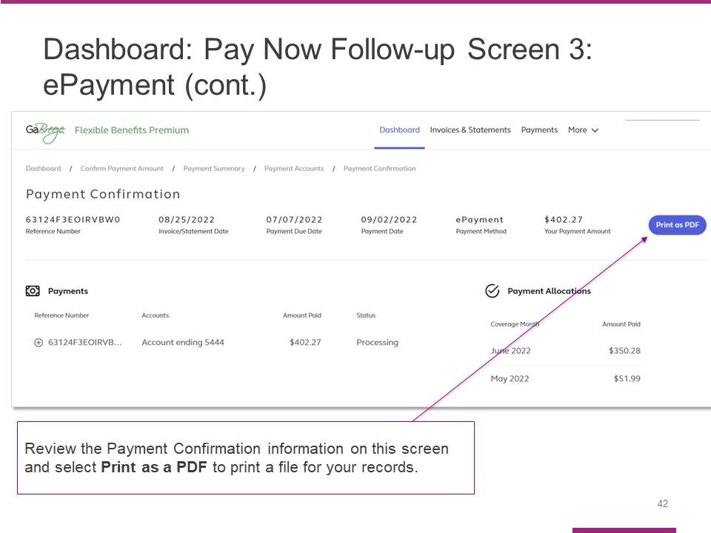

This Payment Confirmation screen will appear after the ePayment is authorized.

The entity’s AP Fiscal Representative or Chief Financial Officer should review and then select Print as a PDF to obtain a copy for your entity’s records.

Slide 43

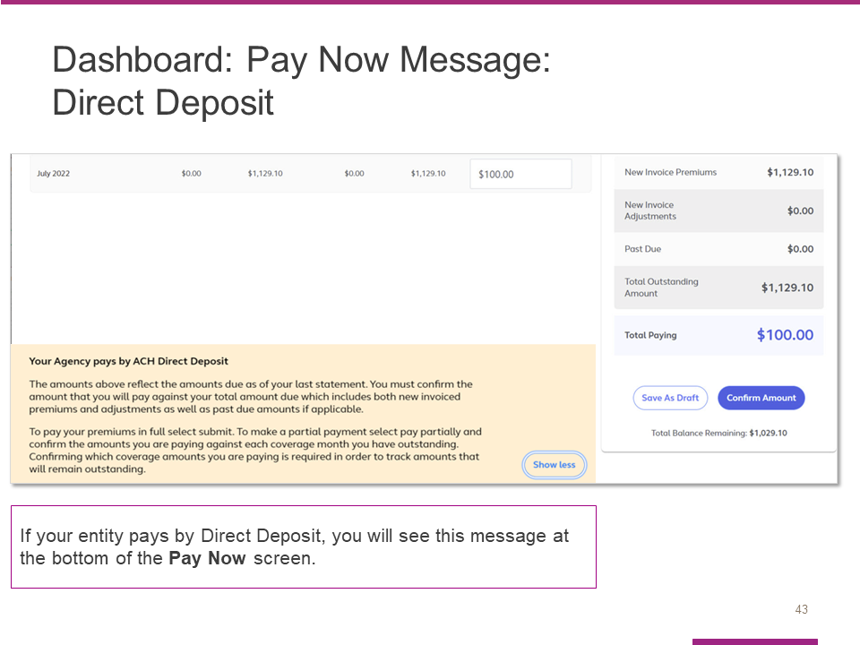

If you are paying by Direct Deposit, you will see this message at the bottom of the Pay Now Screen. Please review before you select Confirm Amount.

Slide 44

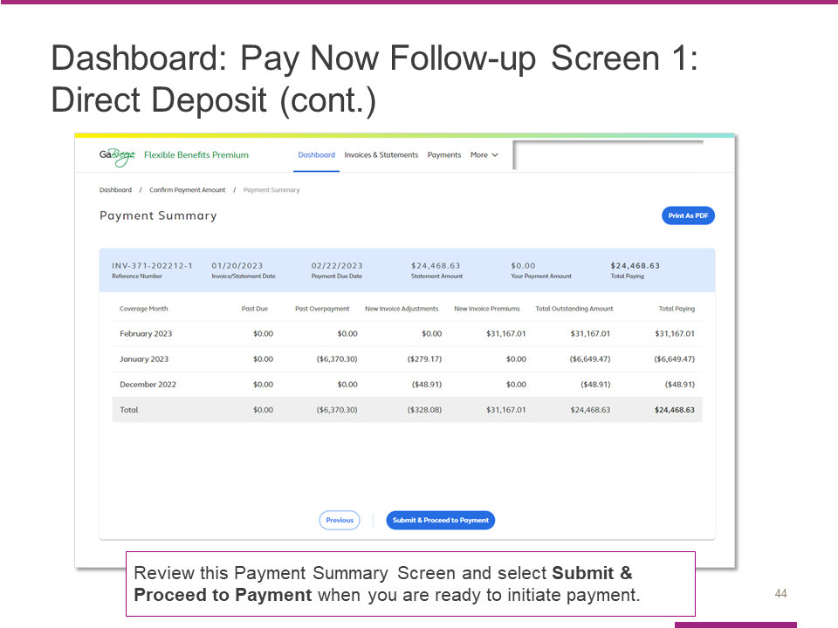

Here is the Payment Summary Screen that appears for entities that pay by Direct Deposit.

Review the summary and then select Submit & Proceed to Payment to begin the payment process.

Slide 45

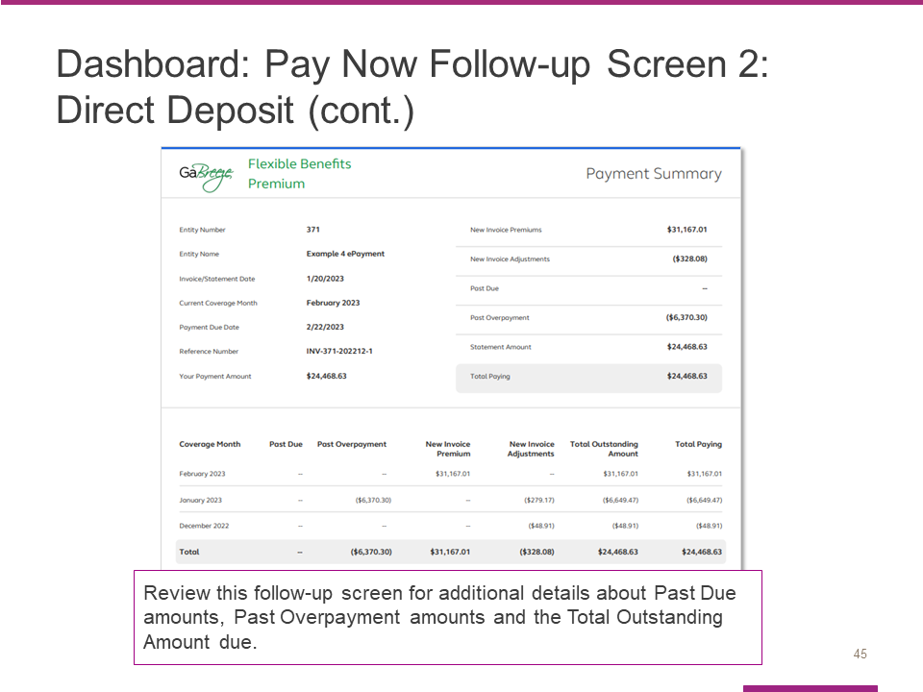

After you begin the payment process, you will see this screen, which contains details about any Past Due amounts, Past Overpayment amounts and your Total Outstanding Amount due.

Slide 46

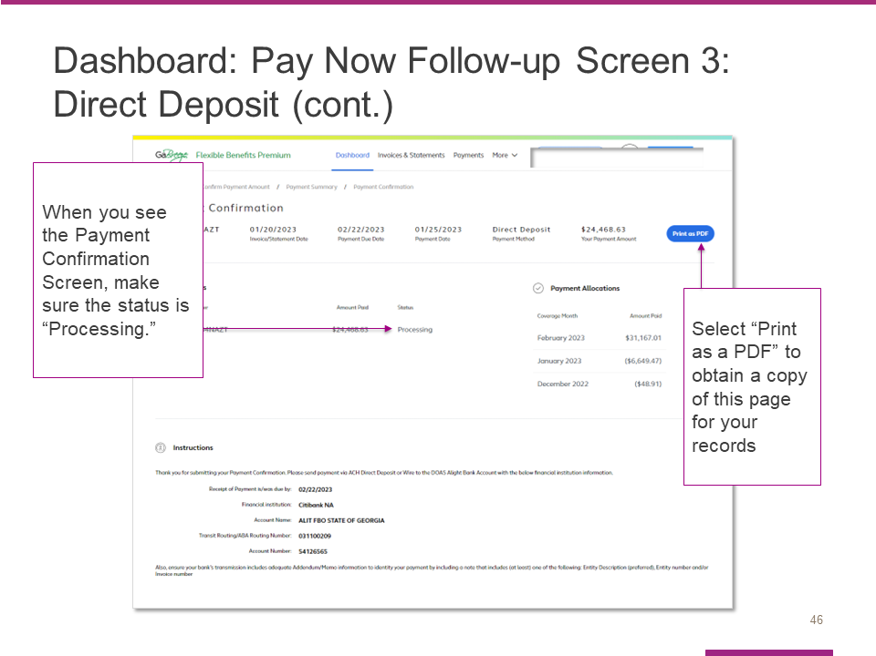

After you begin the payment process, you will see this Payment Confirmation Screen.

Check to make sure the status is Processing.

Select Print as PDF to obtain a copy of this page for your records.

Slide 47

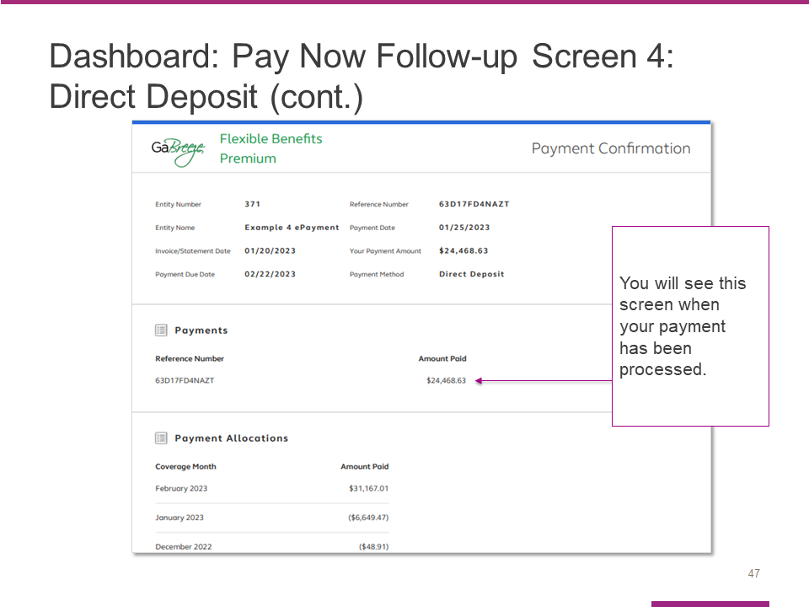

This screen shows what you will see when your payment has processed.

Slide 48

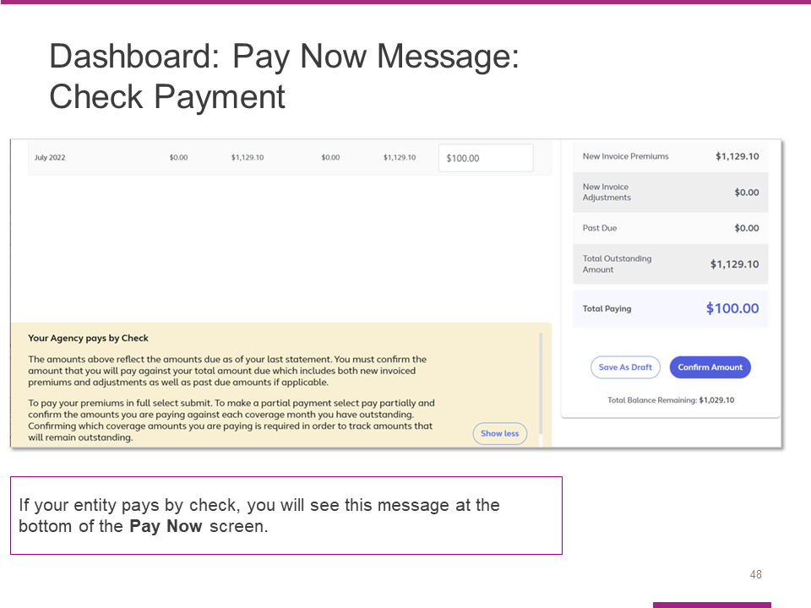

If your entity pays by check, you will see this message at the bottom of your Pay Now screen.

Review this message before you select Confirm Amount.

Slide 49

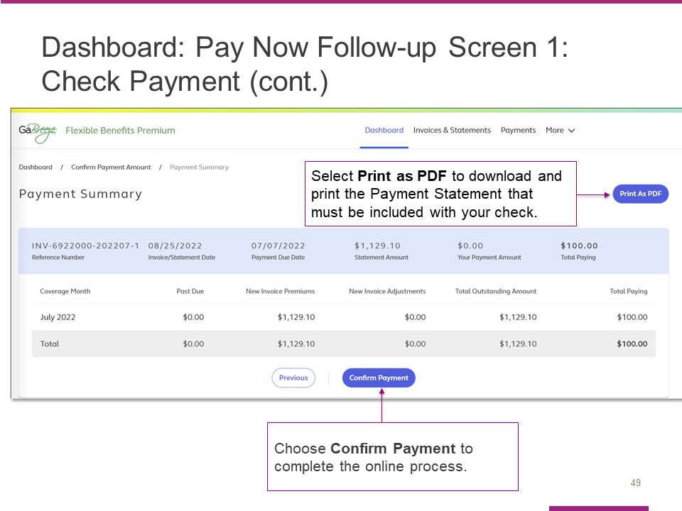
After you confirm your payment amount on the prior screen, you will see this Payment Summary screen. You need to complete two steps to process your payment:
First, select the Print as PDF button to download and print the payment statement/coupon that must be included with your check payment.
- The statement has instructions on where and by when to mail the check. It also includes prepopulated information that facilitates the processing of the check at the Alight/Citi lockbox.
- A manufactured number included on the statement is keyed along with the check.
- Alight Solutions then uses this number to associate the check payment with the correct entity.
Second, after you have downloaded and printed the statement, select Confirm Payment to complete the online process.

Slide 50

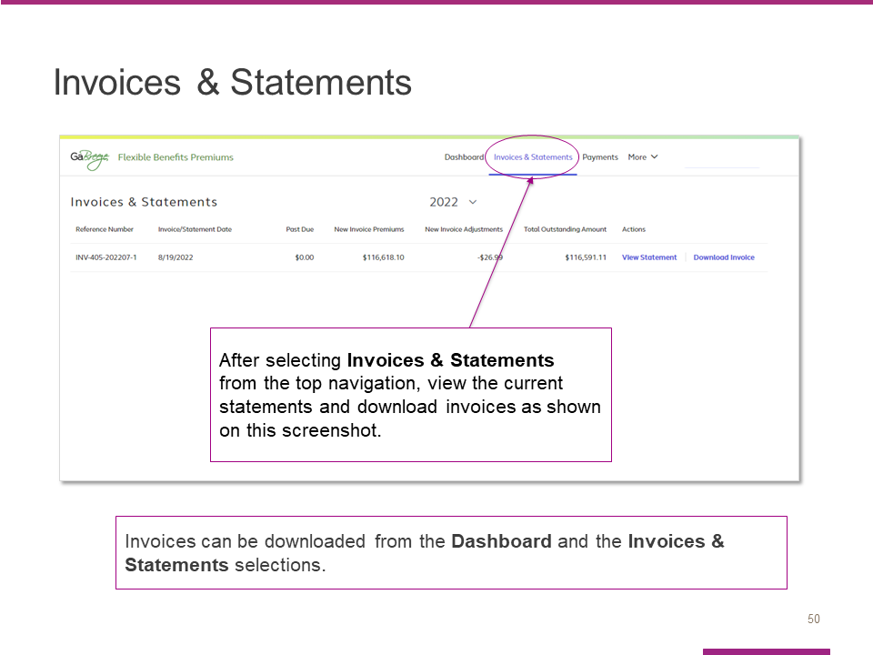

Now we’ll discuss invoices and statements.

The Invoices & Statements link at the top of the dashboard takes you to a page where you can view current statements and download invoices.

Your entity receives both an invoice and statement.

Slide 51

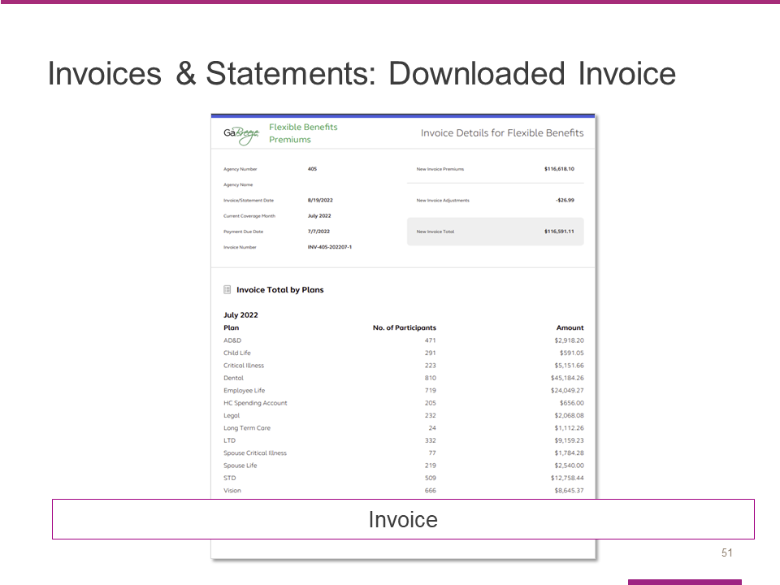

The invoice can be downloaded from the site as a PDF and shared within your entity for financial approval and routing.

Your invoice includes new premiums and new adjustments that have been calculated in the current billing cycle.

Slide 52

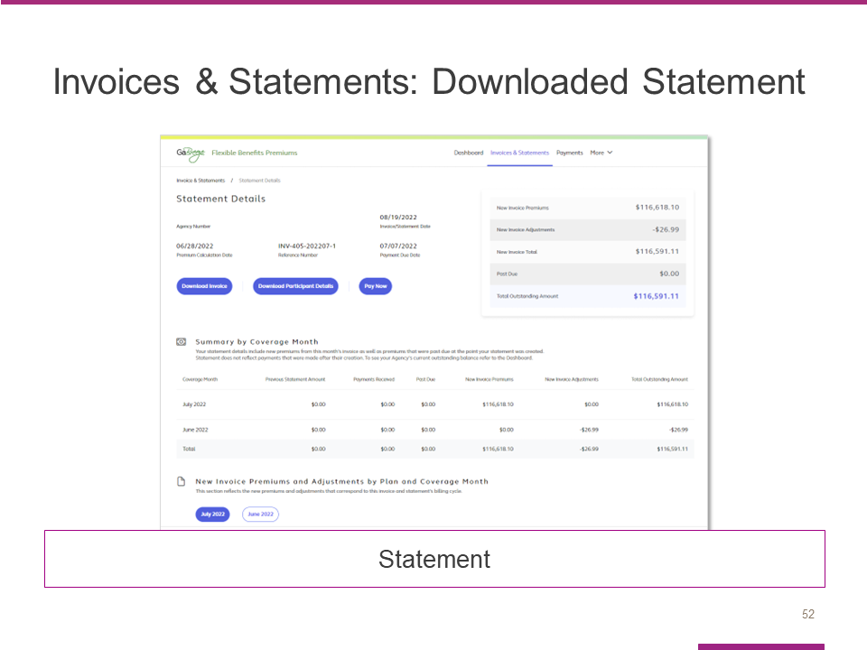

Your monthly statement can be viewed online and shows the same details of new premiums and new adjustments included in your invoice.
In addition, your statement shows payments received since your last invoice/statement.
It also shows any remaining past due balances if any previous invoices were not paid in full when the statement was created.

Slide 53

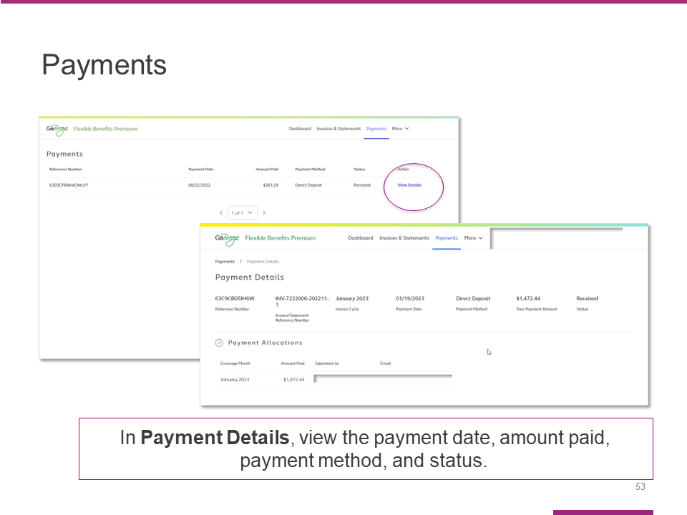

The next link in the top navigation takes you to the Payments page, where you can view the payment date, amount paid, payment method and status.
From the Payments page, you can select the View Details link to reach the Payment Details page.
Once you reach the Payment Details page, you can view the payment date, amount paid, payment method and status.

Slide 54

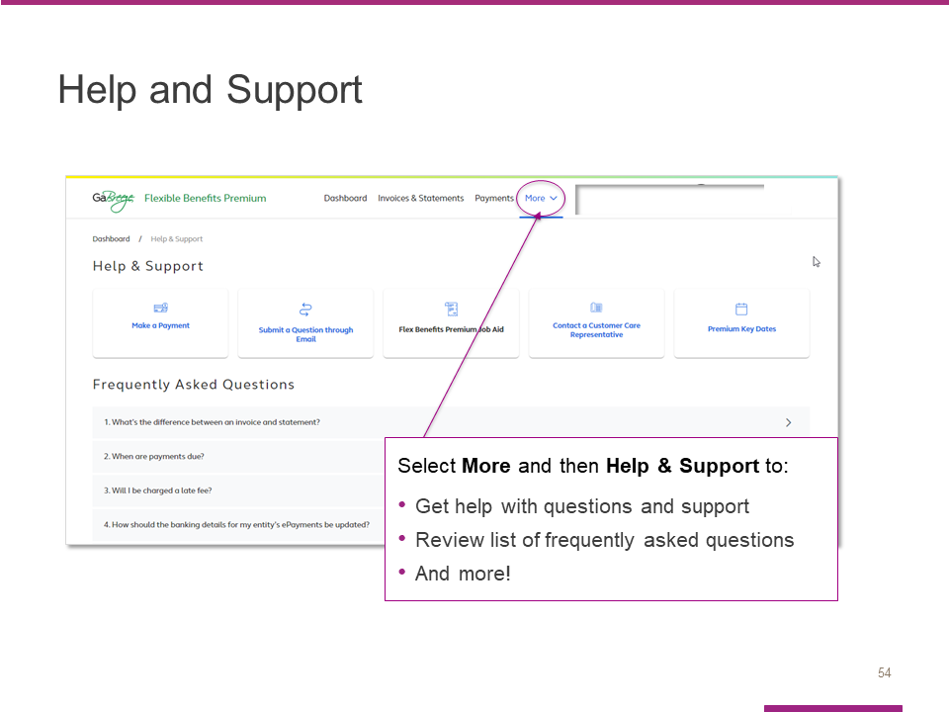

Select More and then Help & Support to:

- Get help with questions and support
- Review list of frequently asked questions, or FAQs
- And more!

Slide 55

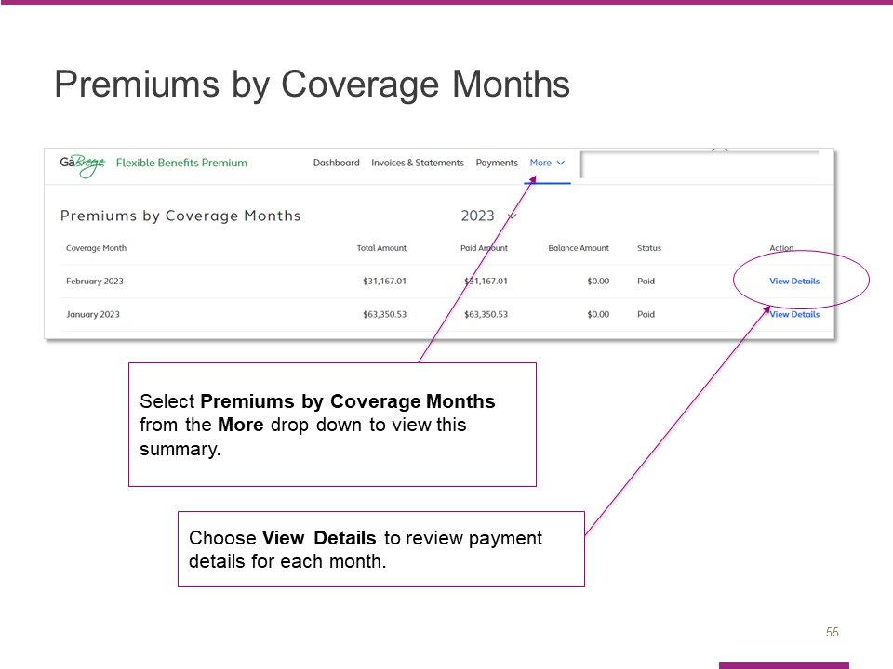

The More menu contains a link to the Premiums by Coverage Months summary page.
After you review the information on this screen, select View Details to proceed.

Slide 56

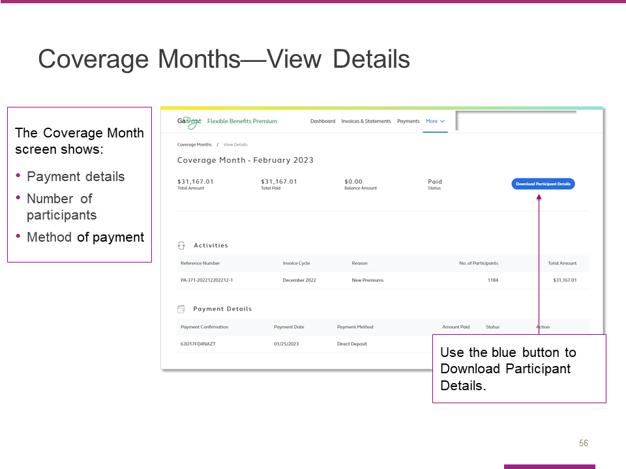

In addition to providing payment details, the View Details page also shows the number of participants and method of payment.

You can also download participant details from this page.

Slide 57

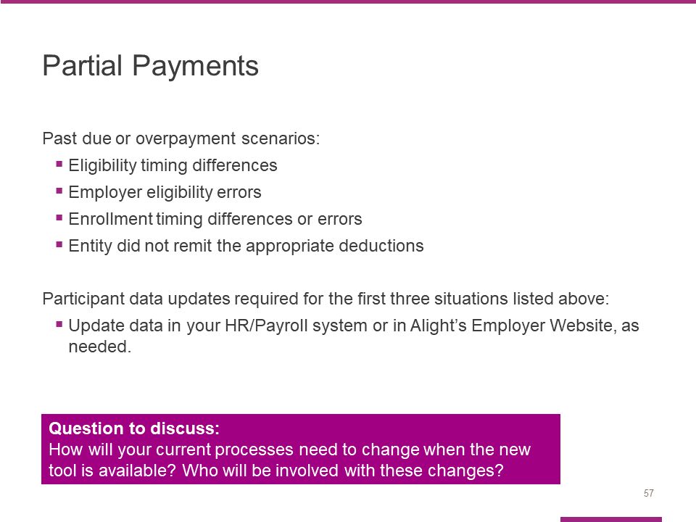

Entities are expected to pay the amounts deducted from payroll or invoiced. Those who do not pay the invoice amount will be considered past due.

The financial payment tool will allow entities to pay amounts less or more than what's invoiced; however, if you pay less than the amount invoiced, the below scenarios will still be treated as delinquent/past due:

- Eligibility timing differences – eligibility changed after an invoices' premiums were calculated vs. when payments are submitted.
- Employer eligibility errors – eligibility updates that were not sent to Alight as expected.
- Enrollment timing differences or errors – enrollment processed after an 'invoices' premiums were calculated vs. when payments are submitted or participants who missed enrollments or enrolled in an unintended option.
- The entity did not remit the appropriate deductions from payroll to cover employees' premiums.

For the first three situations, entities are expected to submit participant data updates.
Automated Hybrid entities, should work with their HR/Payroll teams to make any necessary updates.

Hybrid entities should work with their HR/Payroll teams to make any necessary updates.
Manual entities must use the Employer Website tool to update participant details. This tool is available at http://digital.alight.com/gabreezeemployer/.

Questions to consider: Who will compare the payroll deduction reports to the benefit premium reports? Who will confirm the payments in the tool? Who will ensure the payment is confirmed in the tool prior to the payment being paid to Alight? When will the payroll and benefit reports be compared?

Slide 58

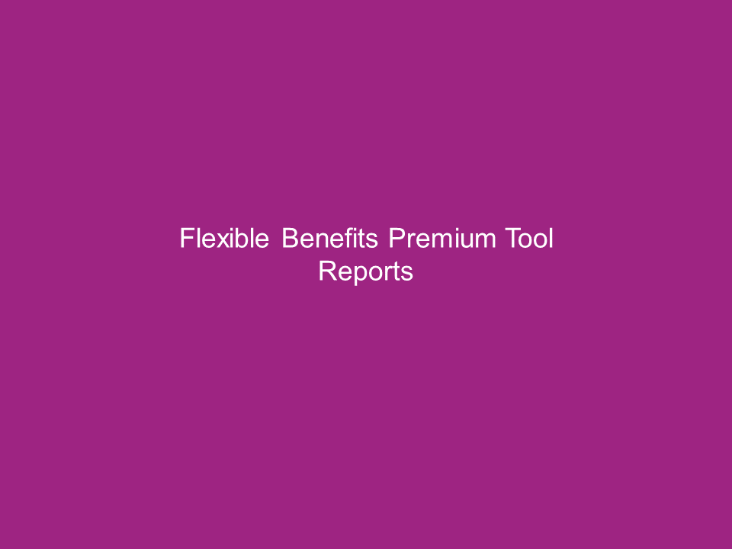

In this section, you will learn more about reports within the tool.

Slide 59

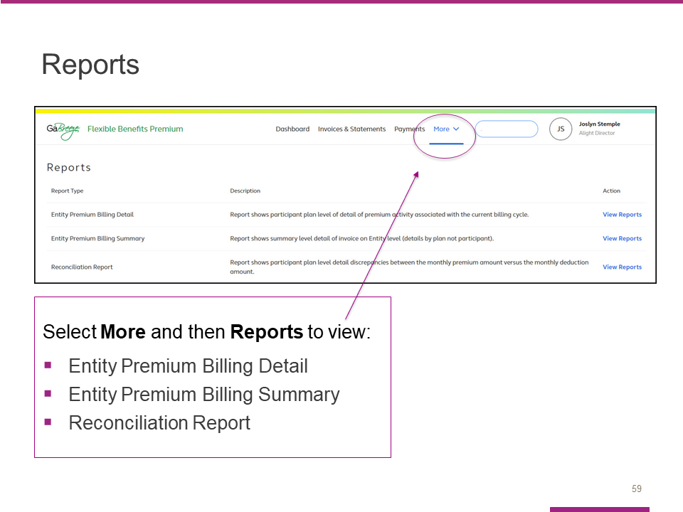
Select More and then Reports to view a screen that lists all available reports, including:
- Entity Premium Billing Detail
- Entity Premium Billing Summary
- Reconciliation Report
You will see a short description of each report as well as a link to the actual report.
Note:
• Entity Premium Billing Detail = FLX Financial Manager Detail Report
• Entity Premium Billing Summary = FLX Financial Manager Summary Report

Slide 60

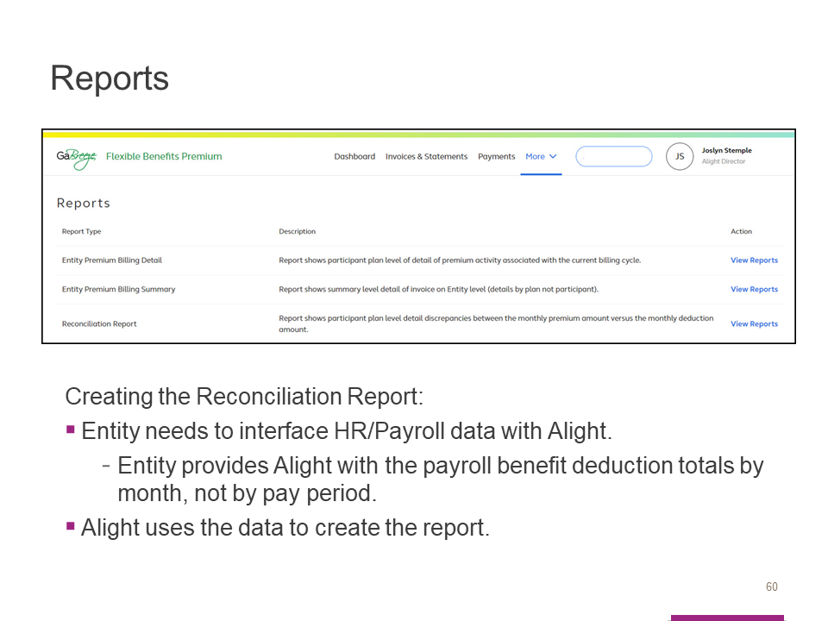

To create the Reconciliation Report:

- Entity needs to interface HR/Payroll data with Alight.

The entity provides Alight with the payroll benefit deduction totals by month, not by pay period.

- Alight uses the data to create the report.

Slide 61

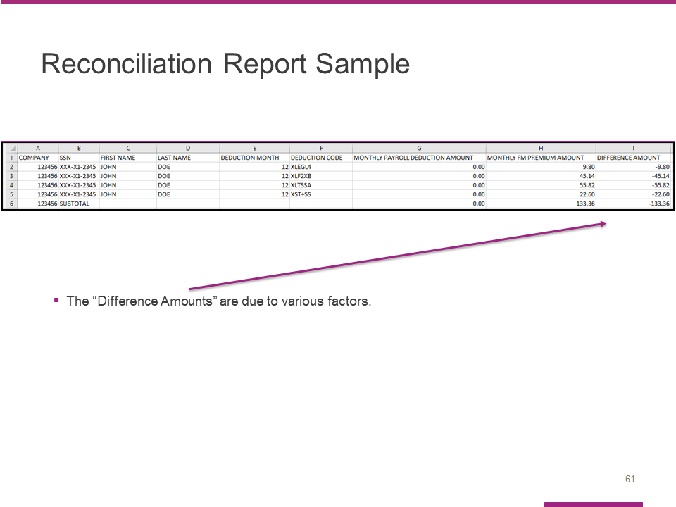

Alight released the new Reconciliation Report in May for TeamWorks Payroll entities. Manual/Hybrid entities, will need to work with Alight to provide payroll data and test the new report.

Note: The Reconciliation Report is an optional report. Entities with 100 or more employees will benefit from receiving the report because the report quickly identifies employees with a difference between their payroll deductions and benefit premium amounts.

The “Difference Amounts” are due to various factors. The Flexible Benefits Reporting Toolkit (FBRT) training that was held in April provided an overview of the common scenarios and the other reports to reference. If you were not able to attend the FBRT training, or watch the video recording, please do so. If you need information about the FBRT training, please send an email to the Flexible Benefits team at flex.emailsupport@doas.ga.gov.

Slide 62

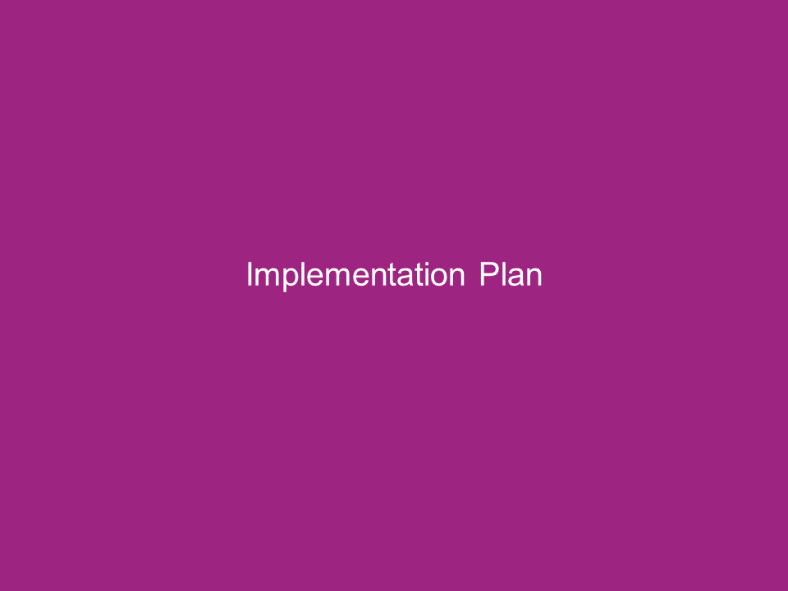

Now, we want to touch on the project timeline and highlight available resources and support.

Slide 63

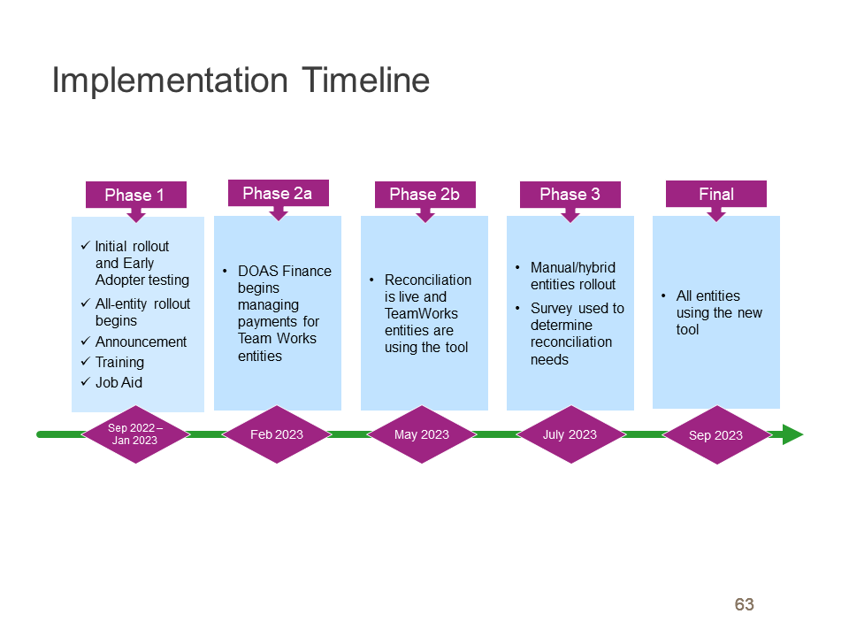

Here is an overview of the implementation timeline.

In Phase 2a, DOAS Finance shared the responsibilities with each TeamWorks entity. Their monthly payments were posted to the tool.

In Phase 2b, each TeamWorks entity received access to use the tool. Phase 2b introduces the new Reconciliation report.

In Phase 3, the Manual/Hybrid entities will begin using the new tool.

Slide 64

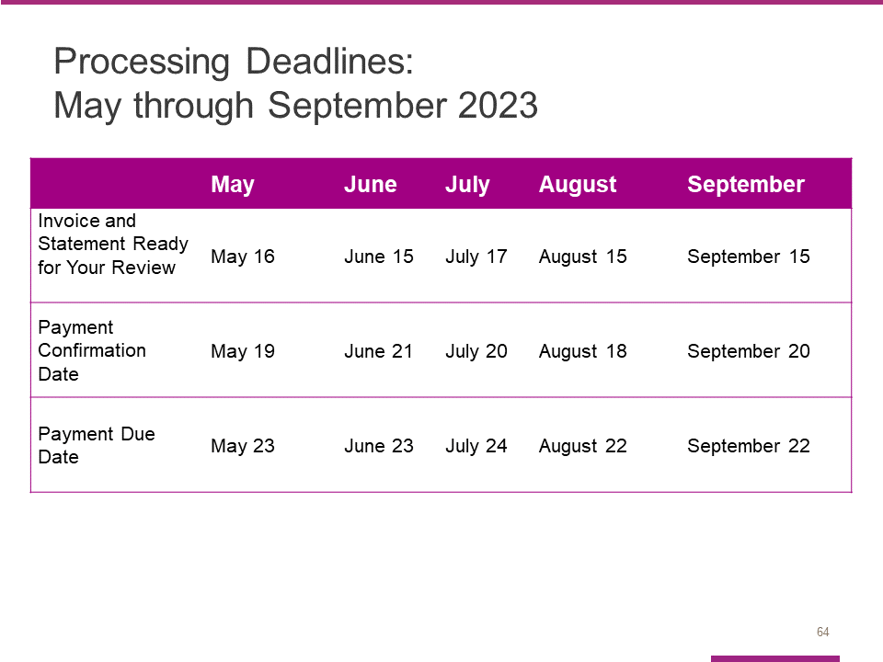

Here are the processing deadlines for the next few months.

Please note, in order to help Alight allocate your payment correctly, confirm your payment in the tool before you send your payment to Alight. If Alight does not receive your payment by the due date, Alight will send an email reminder.

Slide 65

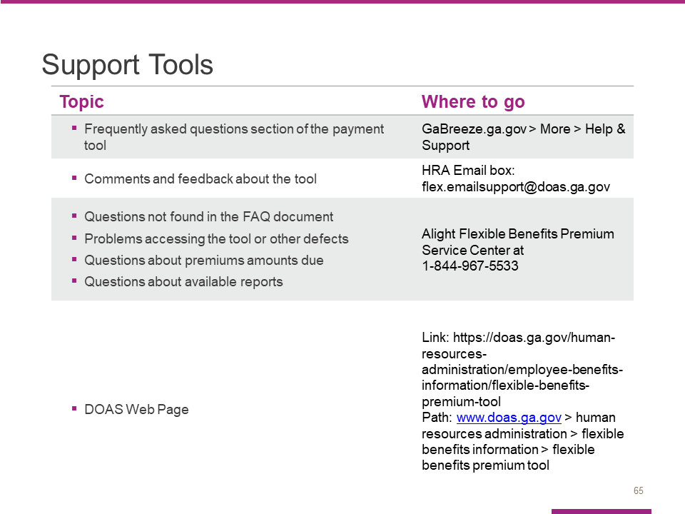

Use these resources if you need help, have questions, or want to provide feedback.

Please note that the FAQs are embedded in the payment tool. There is not a separate document.

Slide 66

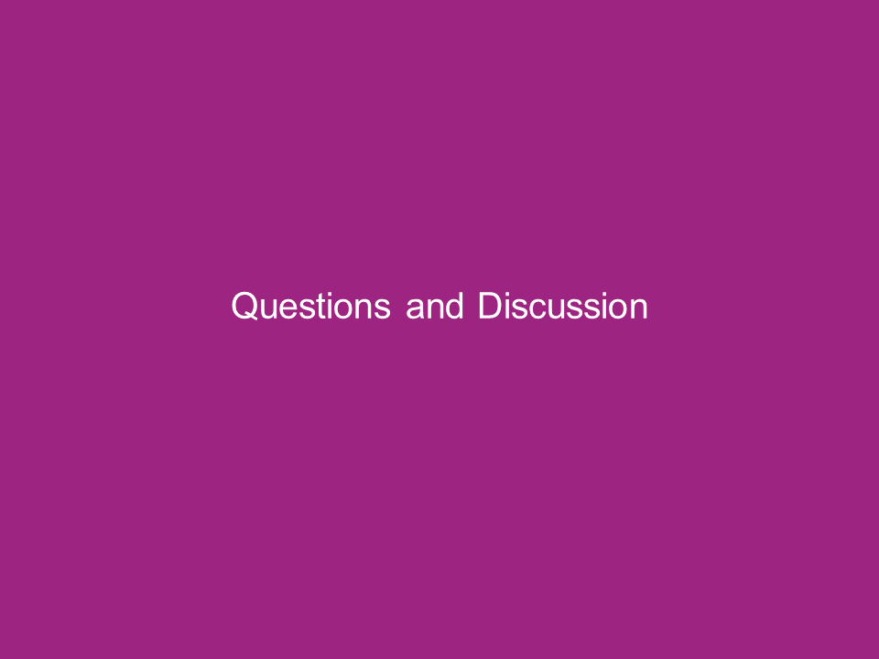

Slide 67

Slide 68

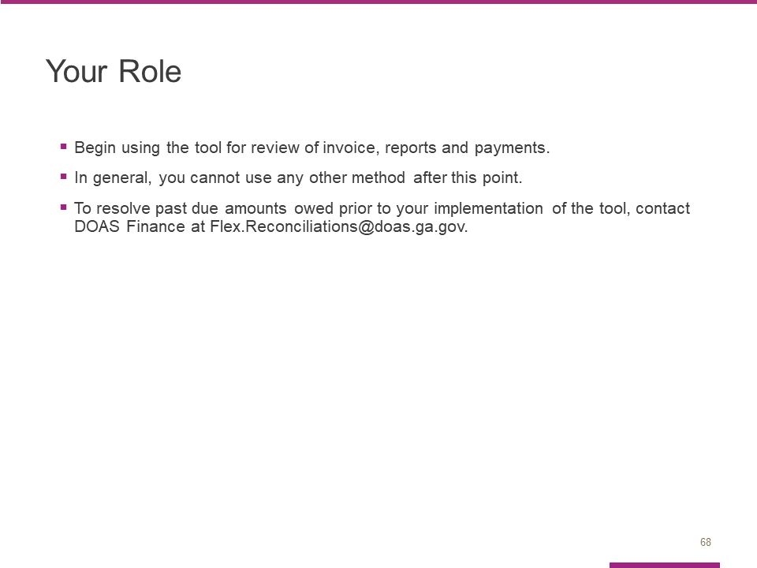

Your Entity is expected to start using this tool after today’s training starting with the June invoice.

In general, you cannot use any other payment methods after today.

To resolve past due amounts owed prior to your implementation of the tool, contact DOAS Finance at Flex.Reconciliations@doas.ga.gov.

Slide 69

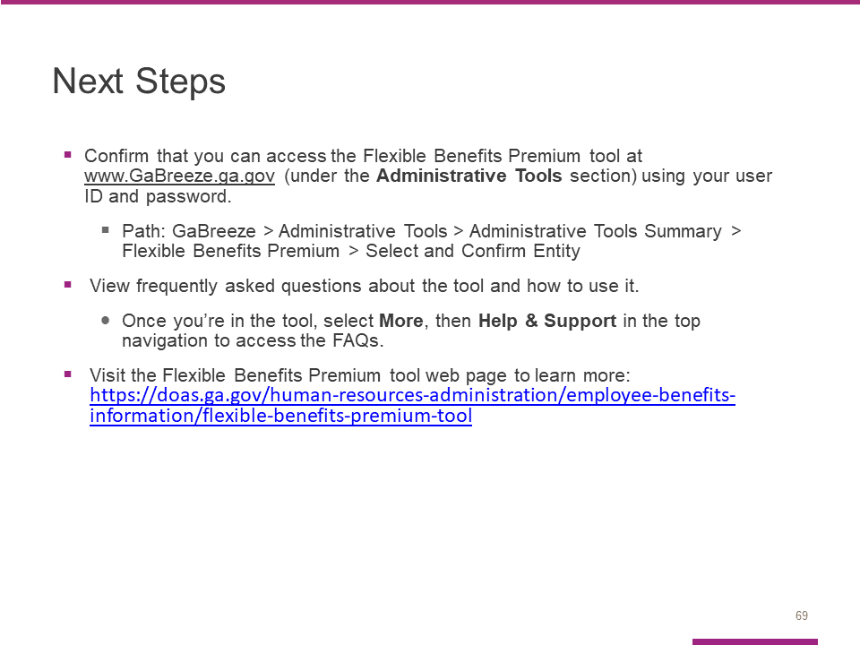

In terms of immediate steps, please take a few minutes to confirm that you can access the Flexible Benefits Premium tool at www.GaBreeze.ga.gov (under the Administrative Tools section)
.
If you experience technical difficulties, please call Alight at 1-844-967-5533 (located in the Support Tools slide). If you have questions about the tool or this training, contact the Flexible Benefits team at HRA.flexbenefits@doas.ga.gov.

Slide 70

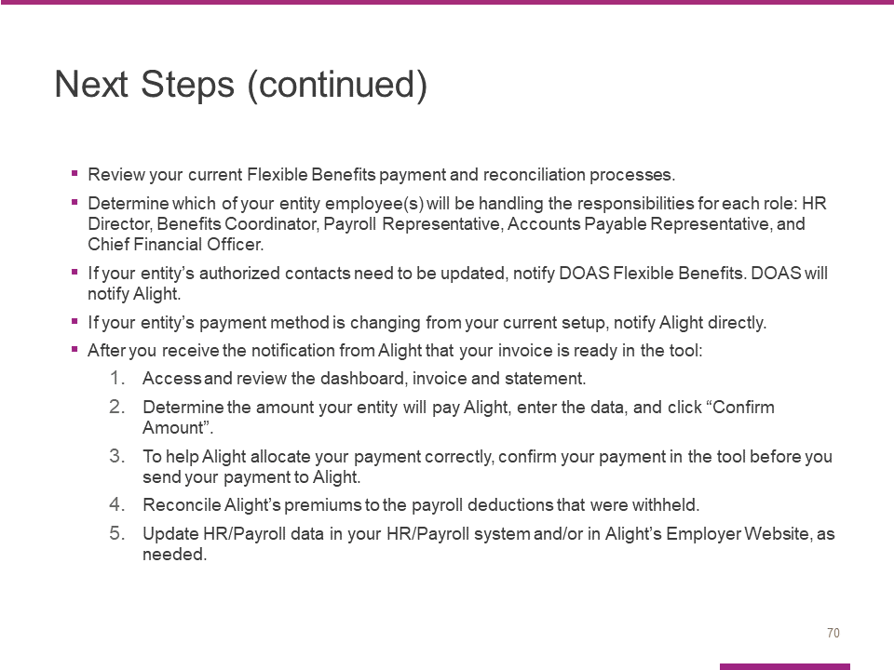

Review your current Flexible Benefits payment and reconciliation processes.

Determine which of your entity employee(s) will be handling the responsibilities for each role: HR Director, Benefits Coordinator, Payroll Representative, Accounts Payable Representative, and Chief Financial Officer.

If your entity’s authorized contacts to access the tool need to be updated, notify DOAS Flexible Benefits. DOAS will notify Alight.

If your entity’s payment method is changing from your current setup, notify Alight directly.

After you receive the notification from Alight that your invoice is ready in the tool:
- Access and review the dashboard, invoice and statement.
- Determine the amount your entity will pay Alight, enter the data, and click “Confirm Amount”.
- To help Alight allocate your payment correctly, confirm your payment in the tool before you send your payment to Alight.
- Reconcile Alight’s premiums to the payroll deductions that were withheld.
- Update HR/Payroll data in your HR/Payroll system and in Alight’s Employer Website, as needed.

Slide 71

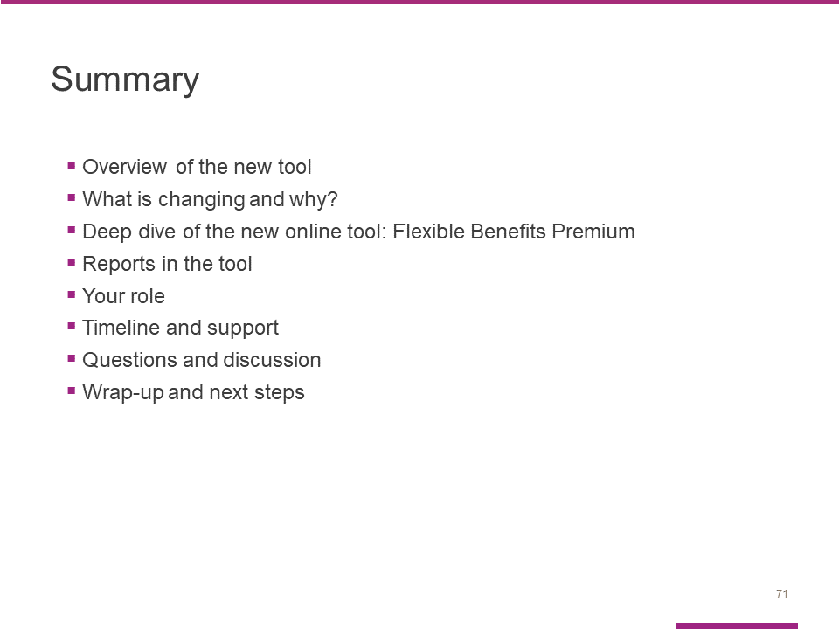

In summary, I presented all the agenda topics.

You learned about the steps that must be completed each month 1) to make your Flexible Benefits premium payments, and 2) the available tools to reconcile your data.

Slide 72

