SETTING UP THE TRANSACTION LIST IN WORKS

- In Works, go to Reports > Create.
- Make the following selections in the Create Report screen:
Category: Spend
Template: Billing Statement
Selected: Columns highlighted in the “Selected” column of Screenshot 1.
Filter: Transaction Type (select the types shown) and Post Date
Post Date: Dates to be included in the report.
Formats: Excel, PDF, Delimited. Full Details under each section.
Save Template to Library: Selected
Template Name: Choose a meaningful name (e.g. Transaction List)
Template Description: List of Transactions
Job Name: Will default to report name. You can edit this when you run it.
- Click Submit.

SCREENSHOT 1:
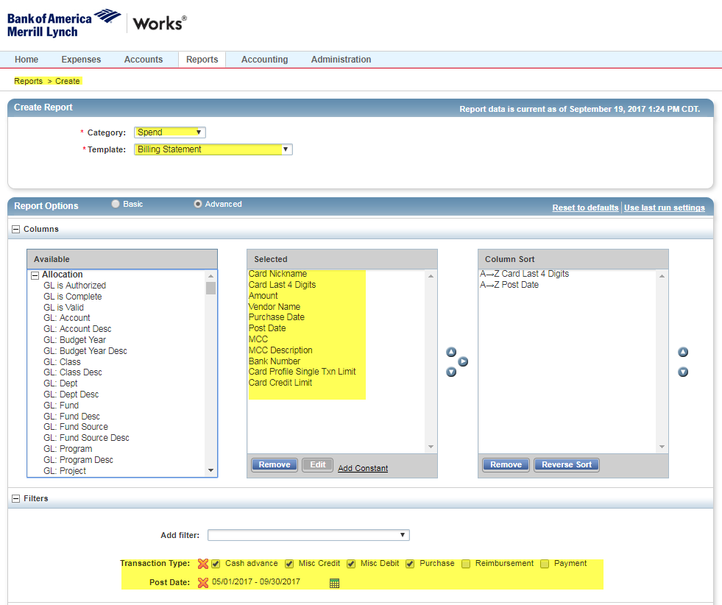

SCREENSHOT 2:
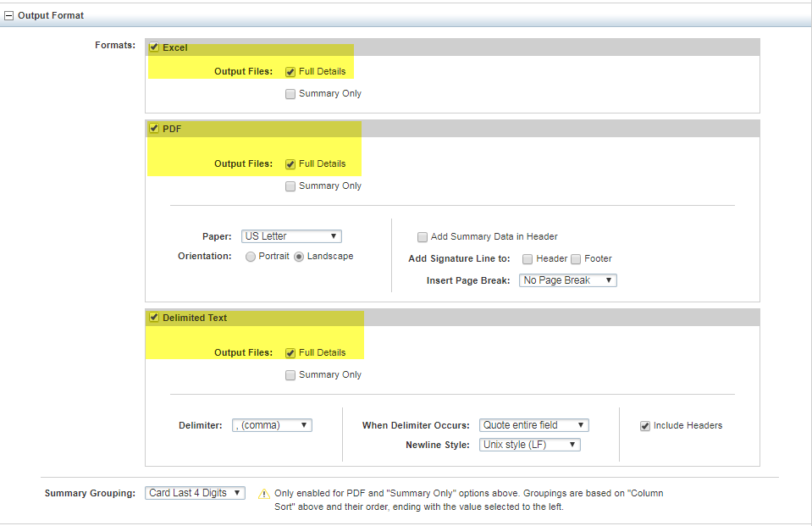

SCREENSHOT 3:
